Deepkumar Patel;Prosley Dorcely;Aaron Weingarten;Jack Corbin;Emily Groth
FAMU-FSU College of Engineering 2525 Pottsdamer St. Tallahassee, FL. 32310

Team 509: “Smart” Projectile
1/13/2023

Abstract
The abstract is a concise statement of the significant contents of your project. The abstract should be one paragraph of between 150 and 500 words. The abstract is not indents.

Keywords: list 3 to 5 keywords that describe your project.

Disclaimer
Your sponsor may require a disclaimer on the report. Especially if it is a government sponsored project or confidential project. If a disclaimer is not required delete this section.

Acknowledgement
These remarks thanks those that helped you complete your senior design project. Especially those who have sponsored the project, provided mentorship advice, and materials. 4

- Paragraph 1 thank sponsor!
- Paragraph 2 thank advisors.
- Paragraph 3 thank those that provided you materials and resources.
- Paragraph 4 thank anyone else who helped you.

Table of Contents
Abstract ii
Disclaimer iii
Acknowledgement iv
List of Tables vii
List of Figures viii
Notation ix
Chapter One: EML 4551C 11
1.1 Project Scope 11
1.2 Customer Needs 3
1.3 Functional Decomposition 5
1.4 Target Summary 8
1.5 Concept Generation 11
1.6 Concept Selection 13
1.8 Spring Project Plan 21
Chapter Two: EML 4552C 22
2.1 Spring Plan 22
Project Plan. 22
Build Plan. 22
Appendices 23
Appendix A: Code of Conduct 24
Appendix B: Functional Decomposition 31
Appendix C: Target Catalog 32
Appendix D: Work Break Down 33
Appendix E: Concept Generation and Morphological Chart 40
Appendix F: Binary Pairwise Comparison 47
Appendix G: House of Quality 48
Appendix H: Pugh Chart 49
Appendix I: Analytical Hierarchy Process 51
Appendix J: Risk Assessment 58
Appendix K: Hazard Types and Examples 66
References 70

List of Tables
Table 1 The Word Table and the Table Number are Normal Font and Flush Left. The Caption is Flush Left, Italicized, Uppercase and Lowercase 10

List of Figures
Figure 1. Flush left, normal font settings, sentence case, and ends with a period. 9

Notation
A17 | Steering Column Angle
A27 | Pan Angle
A40 | Back Angle
A42 | Hip Angle
AAA | American Automobile Association
AARP | American Association of Retired Persons
AHP | Accelerator Heel Point
ANOVA | Analysis of Variance
AOTA | American Occupational Therapy Association
ASA | American Society on Aging
BA | Back Angle
BOF | Ball of Foot
BOFRP | Ball of Foot Reference Point
CAD | Computer Aided Design
CDC | Centers for Disease Control and Prevention
CU-ICAR | Clemson University - International Center for Automotive Research
DDI | Driver Death per Involvement Ratio
DIT | Driver Involvement per Vehicle Mile Traveled
Difference | Difference between the calculated and measured BOFRP to H-point
DRR | Death Rate Ratio
DRS | Driving Rehabilitation Specialist
EMM | Estimated Marginal Means
FARS | Fatality Analysis Reporting System
FMVSS | Federal Motor Vehicle Safety Standard
GES | General Estimates System
GHS | Greenville Health System
H13 | Steering Wheel Thigh Clearance
H17 | Wheel Center to Heel Pont
H30 | H-point to accelerator heel point
HPD | H-point Design Tool
HPM | H-point Machine
HPM-II | H-point Machine II
HT | H-point Travel
HX | H-point to Accelerator Heel Point
HZ | H-point to Accelerator Heel Point
IIHS | Insurance Institute for Highway Safety
L6 | BFRP to Steering Wheel Center

Chapter One: EML 4551C

1.1 Project Scope
Project Description
The United States Air Force is researching the use of an actuating nose cone to enhance endgame course correction of their missiles. This project aims to create a working wind tunnel model of a projectile with an actuating nose cone and dynamically deflectable fins. A dynamic model will facilitate the collection of air flow data in the transient states of missile tip movement, allowing the USAF to develop better controls for their new missile technologies.
Key Goals
The key goals outline the main objectives to be achieved over the course of the project’s design process. For this project, they include:

- Design a projectile with a nose cone that is capable of actuating at least 5 degrees from its axis of symmetry and fins that can deflect 30 degrees from a chosen point of deflection.
- Provide linear output to both the fins and nose cone
- Construct a model of the projectile that is suitable for wind tunnel testing
Primary and Secondary Markets
The primary market is the individual or organization the product will be used by, while the secondary markets are those that may have interest in using or purchasing the product in addition to the primary market.
Primary Market: FCAAP
Secondary Market: 1. Air Force Office of Scientific Research (AFOSR)
2. Air Force Research Laboratory (AFRL)
3. Lockheed Martin
4. General Dynamics
5. Raytheon Technologies
6. Boeing
7. Northrop Grumman
Assumptions
This project assumes that the model is to be used for wind tunnel testing and must withstand the forces associated with it. Therefore, the model’s external surfaces will be fabricated from aluminum, as is standard for tunnel models because of its machinability, strength, lightness, and smoothness The mechanism to make the nose articulate is not designed for full scale, live fire testing. . The model length will not exceed 32 inches to ensure testing is feasible, and deflectable fins will be introduced to the projectile to study their effects. Certain parts will be re-used from the previous year’s project to reduce the overall cost of the project, as well as reduce time spent on ordering parts. New parts or parts that cannot be re-used may be 3D printed or fabricated from other materials. CAD drawings are expected to be finished by early February to allow adequate time for machining and assembly.
Stakeholders
The stakeholders related to this project consist of every individual and group that assisted time and resources into the project. This also includes individuals who guided and influenced different ideas relating to the design of our project. Furthermore, this includes those who would benefit from the background research of the project as well as the testing of the technology designed. Listed below are the stakeholders for this project:
- Florida Center for Advanced Aero Propulsion
- FAMU-FSU College of Engineering
- Air Force
- Dr. Rajan Kumar
- Dr. Jonas Gustavsson
- Dr. Shayne McConomy
- Dr. Suvranu De
- Robert Smith

1.2 Customer Needs
FCAAP has partnered with the FAMU-FSU College of Engineering to develop a Smart Projectile, and advance current projectile technology. FCAAP has connected us with Dr. Jonas Gustavsson who acts as our main liaison to the FCAAP organization. Based on the previous year’s design, we asked the following questions to clarify what the sponsor needs from the project.
Table 1: Customer Interpreted Needs
Questions | Responses | Interpretation
- What are the necessary dimensions of the project? | The L/D ratio should be tested at 8, 12, and 16 to determine which is most optimal, with a set diameter of 2 inches. | A length ranging from 16 to 32 inches and a diameter of 2 inches.
- How far should the nose cone be able to deflect and what is the resolution on that deflection? | The nose should be able to go between 0 and 5 degrees with a resolution of 0.1 degrees. | Induce a nose cone deflection of at least five degrees with a margin of error of 0.1 degrees.
- How quickly should the nose cone move? | The time constant should be optimized to less than 0.5 seconds. | The nose cone can rotate to any position within half a second.
- Besides the deflectable nose cone, what are the other design features you would like to see? | We would like the model to have deflectable fins. The fins can be statically deflectable or dynamic. We will provide the fin type and dimensions in a later meeting. | Develop a static or dynamic deflecting fins.
- What is the type of nose cone that our model uses? | The nose cone will be a tangent ogive that is 6 inches long. | Tangent Ogive with a length of 6 inches.
- What wind speed will the model be tested at? | A normal test speed is 17 m/s, and could go up to 30 m/s. | The projectile can withstand a speed of 30m/s.
- How should the movement of the nose cone be defined? | The nose cone should move and be controlled in a linear fashion with no unnecessary motion. | The nose should move in a straight line to the desired position.
- Are there any specific weight restrictions on the model? | No, but you should strive to keep the model as light as possible as that reduces strain on your mechanism and lessens the amount of vibration of the model in the tunnel. | Try to use the lightest material possible and investigate reducing the weight of current components already implemented.
- What forces should the model be able to withstand? | You should account for the forces and moments associated with the weight of the model. Because the model is being tested in a subsonic wind tunnel, the aerodynamic forces are negligible. | Calculate the forces associated with the weight of the model and include a factor of safety on top of that.
- What material should be used? | Aluminum is preferred. | Projectile is made of Aluminum.

The responses in this table were provided to us by Robert Smith and Dr. Jonas Gustavsson. Based on their responses, we were able to synthesize a list of interpreted needs. These mainly focus on the motion of the nose cone, testing conditions, dimensions, and materials.

1.3 Functional Decomposition
Introduction
The functional Decomposition is the development of our needed systems based on the information provided by the customer. The functional decomposition attempts to arrange all our interpreted customer needs into a form where we can determine which systems are required for accomplishing the goal of our project, along with how each system is broken down and how they interact with each other.
Data Generation
We set out to determine what essential features were needed for our project by analyzing all we have discovered so far about it. Following a conversation with our advisor, we were able to divide our project into three main systems. After that, we broke each system down into its necessary components so that our project could satisfy our requirements.
Hierarchy Chart
The hierarchy chart displayed in Figure 1 represents the overall functional breakdown of our project. Our project has three main systems: nose actuation, control, and structure.
The nose actuation system is responsible for the deflection and roll of the projectile. The control system will oversee the movement of the nose cone and the deflection of the fins. The control system is also responsible for interpretation and transmission of the data in the system. The structure system pertains to everything related to the mechanical capabilities of the material used for the design. These systems were created to fully accomplish the customer needs determined for our project.

Figure 1. Functional Hierarchy Chart
Connection to Systems
The Nose Actuation system has two main mechanical functions: deflection and roll. The deflection of the projectile nose is aimed at changing the motion of the projectile in the yaw and pitch angles to increase its accuracy.
The control system has three major functions: taking user input for the projectile, providing linear outputs for the deflection of the nose, and providing output for the fins. The control system is responsible for the analysis of the input and transmitting the proper output.
The structure system is divided into three main functions: maintaining the rigidity of the body, securing the components, and attaching supports. To validate the rigidity of the structure, it should prevent vibrations and sagging during flight.
Smart Integration
Below is the functional decomposition cross reference table, which outlines the functions and their connections to the sub-systems.
Table 2. Cross Reference Table
System Functional Decomposition
Function | Nose Actuation | Control | Structure
Controls Deflection | X | X
Controls Roll | X | X
Take User Input |  | X
Provides Linear Output for Nose Deflection | X | X
Provides Output for Fins |  | X
Prevents Vibrations |  |  | X
Prevents Sagging |  |  | X
Secures Components |  |  | X
Attaches to Supports |  |  | X

The Nose Actuation system will have a main goal of replicating the data taken in by user input as an output of the projectile model. Controlling how the projectile deflects and rolls will all be based on user input and therefore be linked with the Control system. The Control system will be responsible for collecting as well as interpreting data that is input by the user and transmitting it to a controller. Providing linear output to the nose will be integrated into the Control system, which will play an important role in how the nose actuates, and therefore how the projectile behaves. The Nose Actuation system deals with the Structure system because its goal is to secure the projectile and prevent outside factors from interfering with the desired outputs controlled by the user. The Structure system will also protect the internal components of the projectile which play a part in the Control System due to the wiring and other components that connect to the nose cone and fins.
Action and Outputs
The smart projectile will be capable of withstanding a variety of test conditions, including high angles of attack, and actuating its nose cone with the purpose of changing its motion during flight. The user will input a desired position and the nose cone will move in a straight line to that position. To accomplish this, the projectile will need various control surfaces to adjust its position. The structure contains the internal components while maintaining rigidity of the body during testing. The structure will also be capable of attaching to support to increase stability.

1.4 Target Summary
Introduction
The targets and metrics are critical in engineering design to determine the success or failure of the project. Targets are the numeric value that we are setting out to achieve. Metrics are the ways the targets are measured and increase the overall quality of the project. The targets consist of general targets and critical targets. The general targets are parameters that our project will be designed around. The critical targets are used to determine the success of the project. These critical targets are shown in Table 4. Our targets are determined by performing functional decomposition and inputs from the sponsor and advisors.
Method of Validation and Measurement Tools
The validation of the target with regards to Nose actuation will be accomplished through wind tunnel testing of the model. Within the wind tunnel, the projectile will be able to actuate the nose cone in various ways allowing data to be collected through the force balance. The recorded data by the balance will be processed through MATLAB to derive the aerodynamic coefficients and verify our targets.
The validation of the target with regards to Controls will be based on a microcontroller to determine the response time of the signal. The microcontroller will take user input to provide a linear output for the nose cone. Once the user input has been sent to the microcontroller, we can determine the response time for the signal to perform the specific task.
The validation of the target with regards to Structure will be accomplished by completing a Computed Aided Design (CAD) model of the projectile. This model will be tested in a Subsonic Wind Tunnel to determine the stresses and factors of safety across the entire body. Additionally, Finite Element Analysis (FEA) can be used for the model applying the targeted static pressure to validate the targets.
Derivation of Targets and Metrics
Our project was broken down into three systems: nose actuation, structure, and control. Each of these systems was broken down into multiple functions. By consulting with our advisors and by researching what it would take to fulfill these functions, we developed a list of targets and metrics.
Nose Actuation Targets and Metrics
The target value for the nose time constant is 0.5 seconds, and the target for nose deflection is ±5 degrees. These were both customer needs stated by FCAAP. A method of validation for the time constant can be implemented within the code by setting flags between the time of signal transmission and model output and recording the time difference.
Control Targets and Metrics
For taking user input and providing output to the fins, the target of less than or equal to 6 milliseconds was determined by using the average time it takes for an Arduino to communicate with a computer and adding 2 milliseconds to account for lag time. For providing linear output to the nose, a target of 1 degree per Volt was determined by considering that the nose will need to deflect up to 5 degrees, so only 5 Volts will be needed to supply power.
Structure Targets and Metrics
For attaching to supports, a target of zero disassembled supports was determined since the model will not be able to be tested properly if any supports become detached. For securing components, a value of 0.0625 inches of part displacement corresponds to the smallest length on a standard ruler. It is assumed that the maximum force the wind tunnel will exert on the model is 10 lbs, so to maintain integrity the model will need to withstand this force.
Targets and Metrics Outside of Functions
Additional targets outside of the functions described will include testing an L/D ratio of 8, 12, and 16 to determine which is most optimal, with a set diameter of 2 inches. The reason for these values is that they provide a range that includes previously tested bodies and allows us to compare them with higher and lower L/D values. We decided on a fin actuation time constant equal to the one for nose actuation since ideally the nose and fins should move in unison without lag time between the two. For testing, we aim to implement a power supply that can run for at least 45 minutes. This was taken from the typical flight time for an ICBM to travel 10,000 km, which is 30 to 35 minutes (How Long Does it Take a Nuclear Missile to Travel). Finally, a theoretical maximum weight of 100 lbs was determined after consulting with our advisors.
Summary
In summary, our critical targets and metrics can be viewed in the table below. The critical targets and metrics that are listed are chosen because it is believed that they will be most important to our project’s success. The targets that are listed were arrived at by extensive research, component specifications and standards, as well as consultation with our project sponsor and advisors. As we go through the design process, the design parameters that we choose for our project will be based on the targets that we select. Even though we have set values for our targets, they could be subject to change.
Table 3. Targets and Metrics
System | Function | Target | Metric
Nose Actuation | Control Deflection | ±5° | Angular Position
Nose Actuation |  | Nose Time Constant ≤ 0.5 sec | Time
Fin Actuation |  | Fin Time Constant ≤ 0.5 sec | Time
Structure | Attach to Supports | Disassembled Supports = 0 | Number of Supports
Control | Provide Linear Output for Nose Deflection | 1 Degree/Volt | Degrees per Volt

1.5 Concept Generation
Introduction
To provide our team with a broader range of concepts than brainstorming could provide, concept generation was performed. To accomplish this, a wide variety of concept generation tools were used to produce 100 concepts on how our project could be solved. All these concepts can be found in the appendix. Later, these concepts will be narrowed down in the concept selection process.
Generation Tool
To generate 100 different concepts, multiple generation tools were used. The first and most common tool was brainstorming. Specifically, we used the combine and rearrange part of the SCAMPER method to enhance our imagination. This allowed us to look at specific ideas and alter them slightly to produce innovative ideas which resulted in more focused ideas. Furthermore, after brainstorming our team used biomimicry to generate concepts. This process uses nature and the world around us to generate ideas related to our scope.
Medium Fidelity Concepts
We then chose medium fidelity concepts which were the concepts that we liked the idea of but not enough to use to solve our project. These ideas can be used as reference to see how well our high-fidelity concepts achieve our project’s goals since these concepts only refer to specific objectives.
Table 4: Medium Fidelity Concepts
Concept # | Concept Description
3 | Smart projectile has an interior pulley system that deflects the nose cone to alter flight path
23 | Smart projectile uses a multi-shape fin which can be altered to allow it to find the target and change flight path
59 | Smart projectile uses an internal mass for mechanical control to alter flight path
69 | Smart projectile uses morphing fins that can widen and thin out depending on the forces they are trying to exert
83 | Smart projectile uses thrust vectoring nozzles to articulate the nose cone to a desired deflection

High Fidelity Concepts
Finally, our team selected high fidelity concepts which were concepts that contained ideas that our team was most interested in to solve our project. These concepts were chosen because we believed that they embodied our project scope and would provide us with the best results. These ideas can be seen below and are listed in the appendix.
Table 5: High Fidelity Concepts
Concept # | Concept Description
27 | Smart projectile uses deflectable thrusters to change flight path
34 | Smart projectile uses articulating nose cone and dynamically deflectable fins for flight control
53 | Smart projectile rapidly ejects and retracts internal mass to change flight path

1.6 Concept Selection
Introduction
A multi-stage analytical procedure was utilized to quantitatively narrow down the number of possibilities that were examined before choosing the final concept for our design. The rest of this section describes the methods through which this unfolds.
Binary Pairwise Comparison
The relative significance of each customer's need was first determined using the binary pairwise comparison. To do this, each customer demand was positioned so that it was reflected across the diagonal by placing it across the first row and down the first column. Then, based on whether the row was more significant or less important, each row was compared to its corresponding column and given a 1 or a 0 accordingly. The binary pairwise comparison for our project is shown in the table below. The rows of the chart were then summed to form the importance weight factor for each customer need, representing which of the customer needs are of more importance to attain.
Table 6: Binary Pairwise Comparison

House of Quality
The next stage of the concept selection process was the house of quality. The house of quality is useful in infusing the voice of the customer into the design process. An important part of customer selection is knowing which of your engineering characteristics are the most crucial for the design. The house of quality compares each customer requirement to our engineering characteristics and evaluates how much influence the customer requirement has on the engineering characteristics. A value of 1, 3, or 9 is then assigned based on how critical the requirement is to the characteristic with a 1 being needed and 9 being critically needed. Each requirement was also provided an important weight factor that was determined from the binary pairwise comparison. Each row was then multiplied by the important weight factor and then the column was summed to obtain a raw score for each characteristic.
Table 7: House of Quality
Improvement Direction |  | ↑ | ↓ | ↓ | ↑ | ↓ | ↓
Units |  | Angular position (deg) | Time (ms) | Time (ms) | Force (lbs) | Distance (in) | Number of detached supports
Customer Requirements | Importance Weight Factor | Controls Nose Deflection | Takes User Input | Provides Output for Fins | Maintains Rigidity | Secures components | Attaches to supports
Nose cone deflection of up to 5 degrees with error of ±0.1 degrees | 4 | 9 | 1
Fins that are statically or dynamically deflectable | 3 |  | 3 | 9 |  |  | 1
Projectile can withstand wind up to 30 m/s | 1 |  |  |  | 9 | 3 | 3
Nose moves in straight line to desired position in 0.5 seconds or less | 2 | 9 | 3
Lightweight Material | 0 |  |  |  | 9 | 9 | 1
Raw Score (132) |  | 54 | 19 | 27 | 9 | 3 | 6
Relative Weight |  | 40.91 | 14.39 | 20.45 | 6.82 | 2.27 | 4.55
Rank Order |  | 1 | 3 | 2 | 4 | 6 | 5

Pugh Chart
The Pugh chart is useful for reducing the number of potential designs to a more manageable number. This enables designers to quickly identify the engineering qualities that are most important in terms of the most promising concepts. The initial Pugh chart, shown below, shows how all eight of our high and medium fidelity ideas were evaluated in relation to a datum to see if they performed a function better (+), worse (-), or equally well (S) as the datum. The most utilized and proven design, the basic cylindrical body that uses fin deflection for maneuverability, was chosen as the datum. At the bottom of the chart, the total of each grade was computed, and the idea with the lowest performance was eliminated, while the concept that performed most similarly to the datum was chosen as the next datum.
Table 8: Initial Pugh Chart
Pugh Chart
Function |  | Concept
 |  | #3 | #23 | #59 | #69 | #83 | #27 | #34 | #53
Controls nose deflection | Datum (Basic Body with fin deflection) | + | S | S | S | + | S | + | S
Takes user input |  | S | S | S | S | S | S | S | S
Provides output for fins |  | - | - | - | S | - | - | S | -
Maintains rigidity |  | S | S | - | S | S | S | S | S
Secures components |  | - | S | - | S | S | S | S | S
Attaches to supports |  | - | S | - | - | - | - | S | -
 | Plus (+) | 1 | 0 | 0 | 0 | 1 | 0 | 1 | 0
 | Satisfactory (S) | 2 | 5 | 2 | 5 | 3 | 4 | 5 | 4
 | Minus (-) | 3 | 1 | 4 | 1 | 2 | 2 | 0 | 2

The worst concept, which was eliminated as a potential concept based on the findings from the initial Pugh chart, was #59. Concept #23 was chosen as the datum for the following Pugh chart since it performed satisfactorily for most of the comparisons. Additional Pugh charts, which are included in the Appendix, were also used. The concept that would go on through the Analytical Hierarchy Process was chosen using the final Pugh chart.
Table 8: Final Pugh Chart
Pugh Chart
 |  | Concept
Function |  | #3 | #27 | #34 | #83
Controls nose deflection | Datum (Concept 69) | + | S | + | +
Takes user input |  | S | S | S | S
Provides output for fins |  | - | - | S | -
Maintains rigidity |  | S | S | S | S
Secures components |  | - | S | S | S
Attaches to supports |  | S | - | + | +
 | Plus (+) | 1 | 1 | 2 | 2
 | Satisfactory (S) | 3 | 2 | 4 | 3
 | Minus (-) | 2 | 3 | 0 | 1

Analytical Hierarchy Process
The Analytical Hierarchy Process (AHP) was the final part of the concept selection process that was used to make sure our decisions were not biased. In this process, we compared the engineering characteristics to each other and provided them a number (either 1, 3, or 5) based on how we interpreted their overall importance in order to check the overall consistency of our selections seen in Appendix ___. The values were summed, and a normalized criteria comparison matrix was formed by taking the value of each cell and diving it by its summed value shown in Table 10.
Table 10: Normalized Criteria Comparison Matrix
Normalized Criteria Comparison Matrix
Criteria | Controls nose deflection | Takes user input | Provides output for fins | Maintains rigidity | Secures components | Attaches to supports | Criteria Weight {W}
Controls nose deflection | 0.072 | 0.063 | 0.031 | 0.086 | 0.083 | 0.083 | 0.070
Takes user input | 0.072 | 0.063 | 0.031 | 0.051 | 0.083 | 0.083 | 0.064
Provides output for fins | 0.214 | 0.187 | 0.095 | 0.086 | 0.083 | 0.083 | 0.125
Maintains rigidity | 0.214 | 0.313 | 0.281 | 0.259 | 0.250 | 0.250 | 0.261
Secures components | 0.214 | 0.187 | 0.281 | 0.259 | 0.250 | 0.250 | 0.240
Attaches to supports | 0.214 | 0.187 | 0.281 | 0.259 | 0.250 | 0.250 | 0.240
SUM | 1.000 | 1.000 | 1.000 | 1.000 | 1.000 | 1.000 | 1.000

The average of these cells was then used to create criteria weights. By dividing each cell by the weight of the corresponding criterion, and averaging the results, a weighted sum vector was created. After that, a consistency vector was created by dividing their weighted total by the weight of the criterion. The consistency index and consistency ratio were calculated using the average of the consistency vectors. The consistency check showed that we successfully overcame our bias since the consistency ratio (CR) is less than 0.1.
AHP Design Alternatives
At accordance with the Analytical Hierarchy Process, we compared our top three design concepts for each function in this round of concept selection. Table 11 shows the entire process for a single function, Controls Nose Deflection. First, the effectiveness of each thought is evaluated piecewise with respect to the function. In the second section of the table, the total for each notion is then normalized and compared. These normalized values are then averaged, recorded to the right with the weight of the criterion (Pi), and utilized subsequently in the decision-making process. The method is then given one last consistency check to make sure there was no bias present. Consistency ratios less than 0.1 serve to signify this.
Table 11: Control Nose Deflection Comparison
Controls Nose Deflection Comparison [C]
 |  | Design #3: |  | Design #34: |  | Design #83:
Design #3: |  | 1.000 |  | 0.333 |  | 3.000
Design #34: |  | 3.000 |  | 1.000 |  | 3.000
Design #83: |  | 0.333 |  | 0.333 |  | 1.000
SUM: |  | 4.333 |  | 1.666 |  | 7.000
Normalized Controls Nose Deflection Comparison [NormC]
 |  | Design #3: | Design #34: |  | Design #83: | D.A.P {Pi}
Design #3: |  | 0.231 | 0.200 |  | 0.429 | 0.287
Design #34: |  | 0.692 | 0.600 |  | 0.429 | 0.574
Design #83: |  | 0.077 | 0.200 |  | 0.142 | 0.140
SUM: |  | 1.000 | 1.000 |  | 1.000 | 1.000
Consistency Check
{Ws}={C}{Pi} | {Pi} | Cons={Ws}./{Pi}
Weighted Sum Vector | Criteria Weights | Consistency Vector
0.860 | 0.287 | 2.997
1.721 | 0.574 | 2.998
0.419 | 0.140 | 2.993

This process was repeated for each function, and it was determined that through all consistency checks that there was no bias in the comparisons.
AHP Final Rating Comparison
The final part of the AHP was to create our final rating matrix to decide our final concept. The weights of each design for the engineering characteristics were taken from the design alternatives and were summed for each concept and displayed in Table 12.
Table 12: Final Rating Comparison
Final Rating Comparison
Selection Criteria | Design #3: | Design #34: | Design #83:
Controls Nose Deflection | 0.287 | 0.574 | 0.140
Takes User Input | 0.333 | 0.333 | 0.333
Provides Output for Fins | 0.096 | 0.674 | 0.230
Maintains Rigidity | 0.333 | 0.333 | 0.333
Secures Components | 0.143 | 0.429 | 0.429
Attaches to Supports | 0.333 | 0.333 | 0.333

The transpose of the final rating matrix was then multiplied by the criteria weights resulting in Table 13.
Table 13: Final Selection
Concept | Alternative Value
Smart projectile has an interior pulley system that deflects the nose cone to alter flight path | 0.258482
Smart projectile uses articulating nose cone and dynamically deflectable fins for flight control | 0.47494
Smart projectile uses thrust vectoring nozzles to articulate the nose cone to a desired deflection | 0.266536

Through this process, we determined that the best design for our project would be Concept #34. This can be seen in Table 13.
1.7 Operation Manual
Overview
The Florida Center for Advanced Aero-Propulsion (FCAAP) plans to further its research of an articulating nose cone for missile flight control. By articulating the nose cone of a projectile, a pressure difference is created which causes a change in its direction during flight. Currently, operational missile technologies only involve fins and canards for flight control. With the implementation of an articulating nose cone, its effects on aerodynamics will be studied via testing in the low-speed wind tunnel at FCAAP. This will be tested in combination with deflectable fins.
Project Objective
The objective of this project is to create a scale model of a projectile with an articulating nose cone and deflectable fins for subsonic wind tunnel testing.
Key Goals
There are a few main goals that will try to be achieved upon the completion of this project.
- The nose cone will reach a range of ± 5° of deflection after the linear motion is accounted for.
- The fins will reach a range of ± 30 ° of deflection
- The time constant for the nose cone and fins will be no more than 0.5 seconds.
Components/Integration
Listed below are the steps of how to assemble the projectile and a detailed description of each component and the role they play in the model.
- Back Body
The back body is the rearmost portion of the projectile body. This is where the fins are attached and where the mechanism to operate the fins is contained. The motors are contained within a motor housing, and the gears are configured perpendicular to each other. The gears that are connected to the fins are held in place by a flared base at the end of each fin shaft.
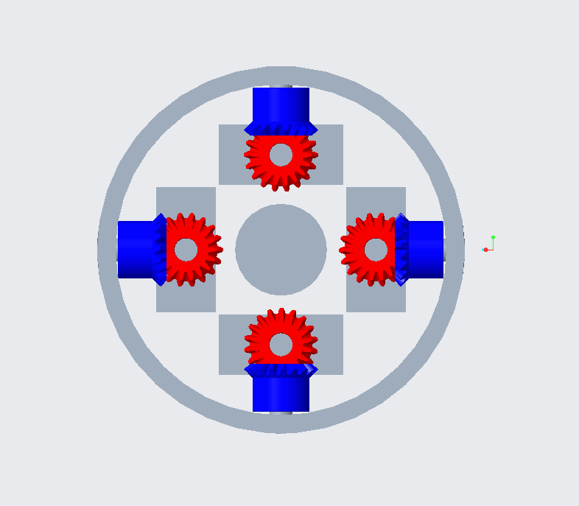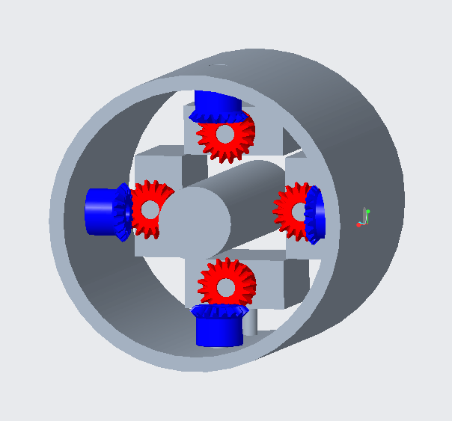
- Miter Gears
The miter gears are made of nylon plastic and have an outer diameter of 0.4 inches, and a pitch diameter of 0.375 inches. They are used in the motor configuration in the back body.
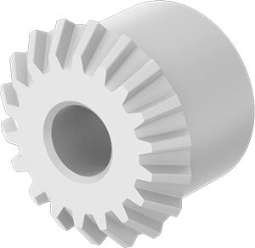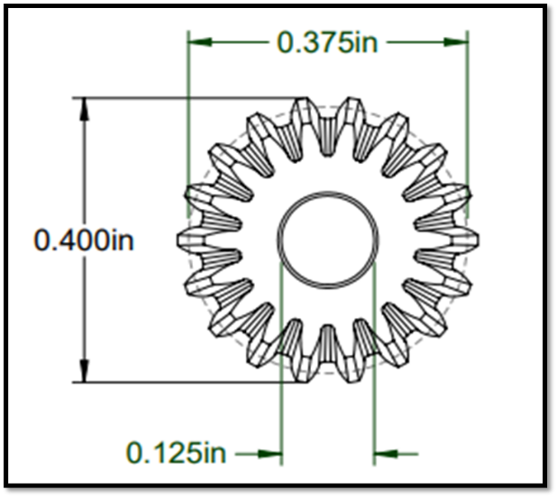
- Fin shaft
Four steel shafts are used, one for each fin. Each shaft is inserted into a hole in the fin, with its opposite end inserted into a miter gear. This miter gear is contained within the back body.
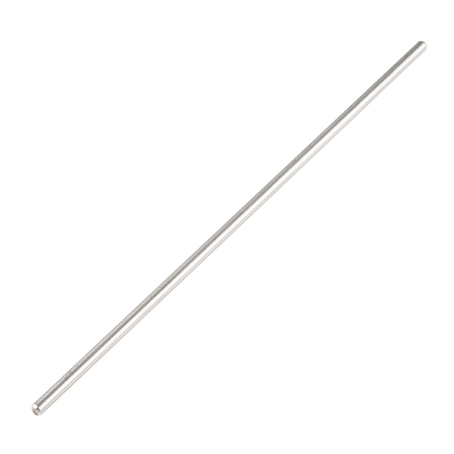

- Servo Motor
Four sub-micro servo motors are placed in the back body to operate the fins. Each motor is aligned with its axis of rotation directed parallel to the projectile body. They each rotate a configuration of 2 miter gears, which outputs motion to each fin.
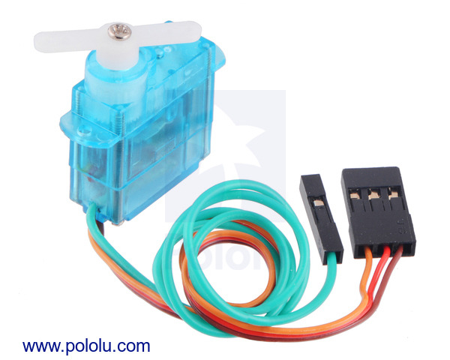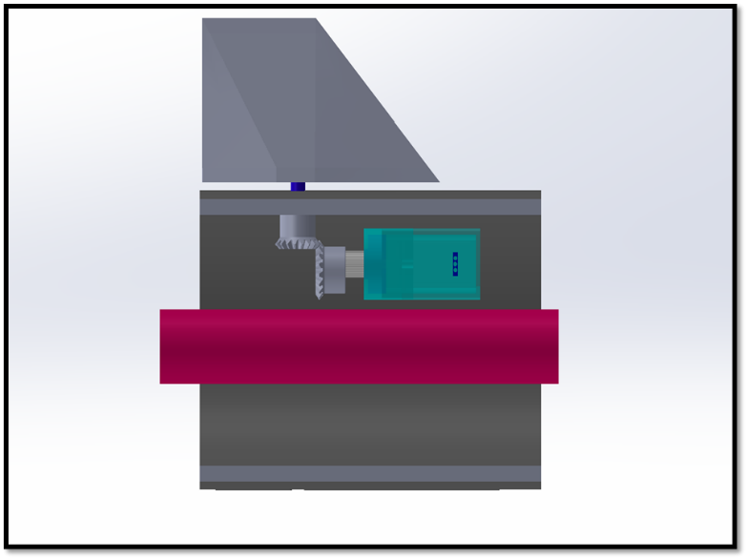

- Servo Motor Housing
A 3D printed insert is used to hold servo motors and gears in place to keep the gears, servo, and shaft connections in alignment from with one another. There is a 0.505-inch diameter hole in the center of the insert to fit the supporting rod and two other 0.89-inch holes to fit the servo motors into the insert.
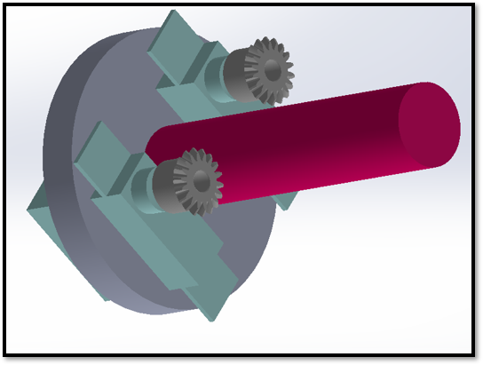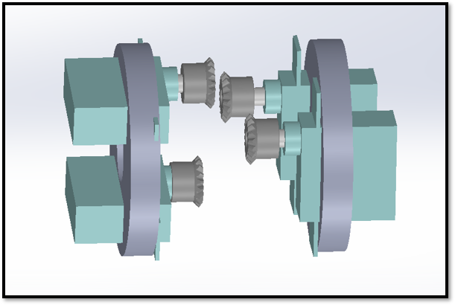
- Supporting Rod
The rod is placed in the center of the projectile body and runs along its entire length. It extends beyond the back of the projectile to allow mounting during wind tunnel testing. It is 0.5 inches in diameter.
- Fins
There are four fins, all placed on the back body of the projectile. They are aligned symmetrically, with each fin placed 90 degrees from one another. Each fin is 2 inches in length and 0.14 inches thick at its thickest section. A hole is drilled into each fin with a shaft inserted inside to attach to the model. They are made of Aluminum 6061.
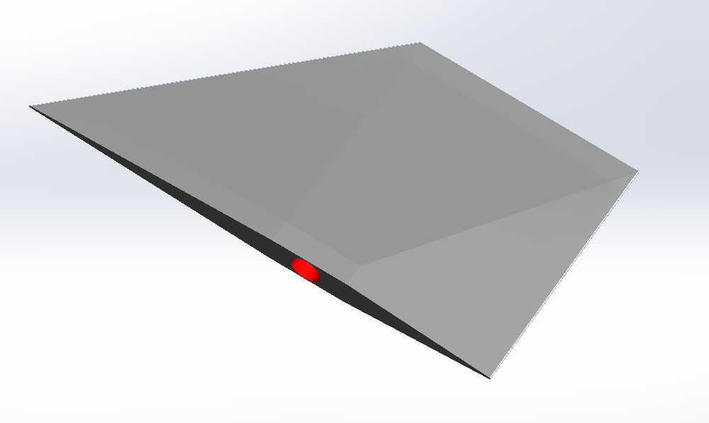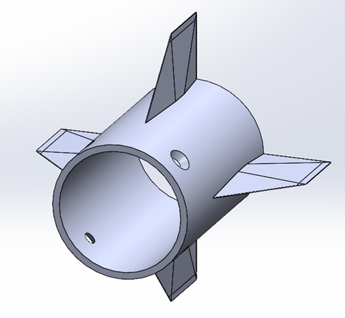
- Middle Outer Body
The middle outer body contains several parts including the long shaft motor, back motor mount, and cross roller bearing. This component holds the rolling mechanism of the assembly and mounts on the force balance to gather data from testing. This part is made from Aluminum 6061.
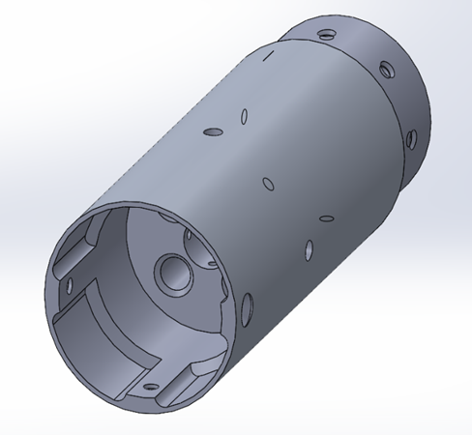

- Back Motor Mount
The back motor mount's purpose is to mount two parts, the rear rotation motor, as well as two bearings. This part is made from Aluminum 6061 and is installed in the middle outer body using three 6-32 screws.
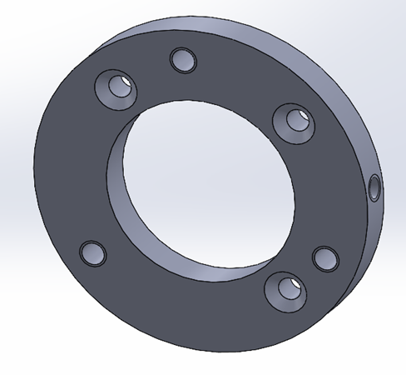
- Frontal Outer Body
The frontal outer body holds the frontal motor mount and mounting hub. This part can rotate freely of the middle body. The chamfer on the frontal outer body allows wires to pass through freely.
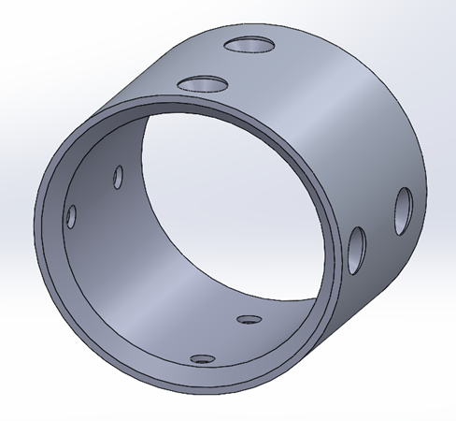
- Bending Sleeves
The bending sleeves are cylindrical pieces that are flexible. They are placed over the entire deflection mechanism.
- Bronze Inserts
The bronze inserts can be found on both sides of the rear deflecting surface’s flange. They are used to reduce the friction between the contact surfaces and the collar. These inserts are both made of 932 Bearing Bronze.
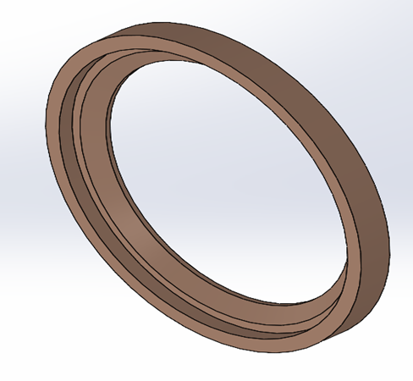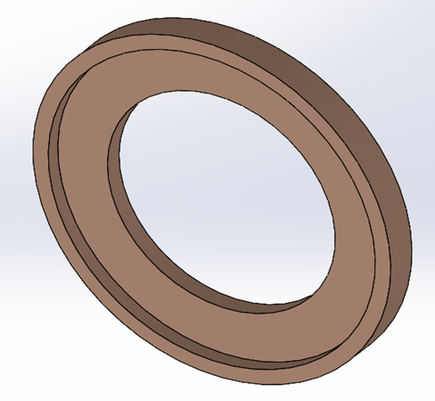
- Collar
The purpose of the collar is to keep both contact surfaces in place, so it is placed over the two deflecting surfaces. The collar slides over and is therefore installed in the front deflecting surface. With both bronze inserts in place, the collar cap is installed over the opposite end and then tightened down. The collar is made from Aluminum 6061.
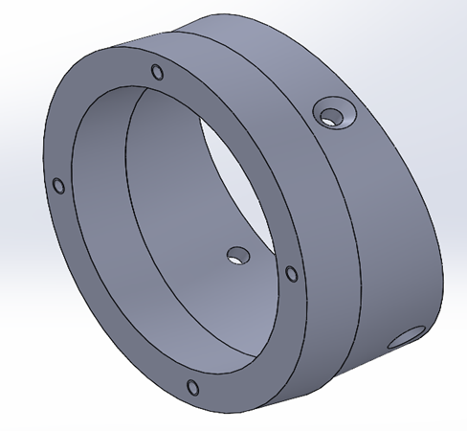

- Collar Cap
The collar cap is installed over the collar and brass inserts. This part will allow the brass inserts place and keeps a tight hold on contact surfaces.
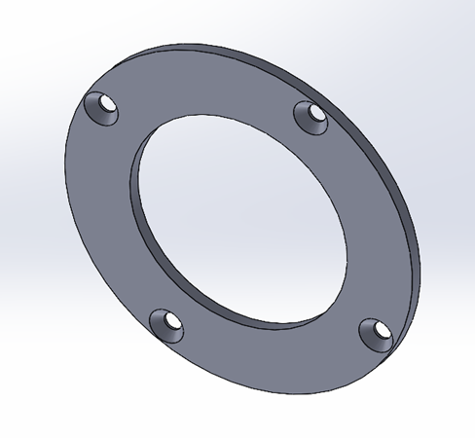
- Frontal Deflecting Surface
The frontal deflecting surface is installed on the cross-roller bearing mounted to the nose cone. This part is rotated using the rotation pin driven by the short shaft motor. This part is made from Aluminum 6061.
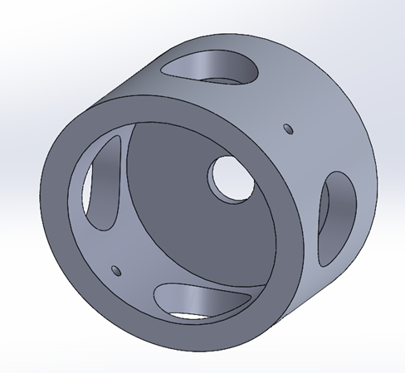
- Frontal Motor Mount
The frontal motor mount holds the short shaft motor used to deflect the nose cone. This part is installed on the inside of the frontal outer body on the non-chamfered side. This part also holds the frontal deflecting surface which is installed on the protruding cylinder.
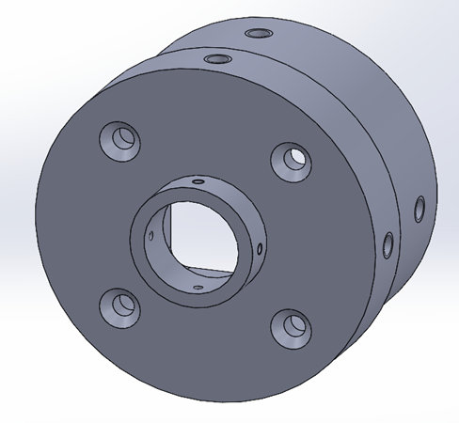
- Face-Mounted Cross Roller Bearings
Two face-mounted cross roller bearings are used for the assembly of the model. One can be found placed on the back motor mount and mounting hub. This allows for free rotation for the frontal section and middle section of the outer body which helps the parts maintain axial position. The second bearing can be found between the nose and the sleeve cuff. This will allow the nose cone to rotate without too much torque being applied to the bending sleeve.
- Stepper Motor
Two NEMA 11 DC motors are used to deflect and rotate the nose cone. One is a long-shaft motor which is installed on the back motor mount and inserted within the middle outer body. The shaft is contained within the mounting hub and held in place by a set screw. This allows the frontal outer body to rotate. The other motor is a short-shaft motor and is installed on the frontal motor mount and held inside the frontal outer body. The universal joint is placed on the shaft and a 1/16” diameter spring pin is used to hold the components in place. This allows for deflection of the nose cone.
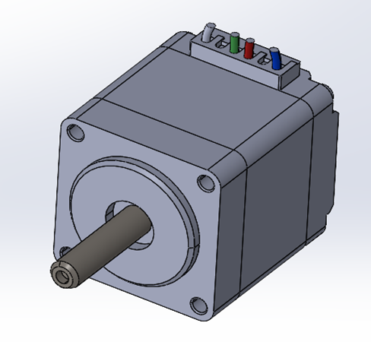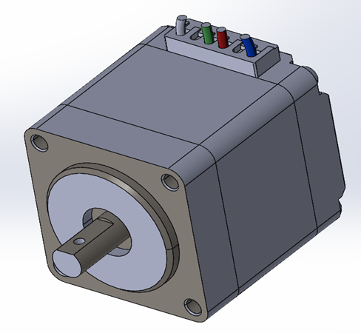
- Mounting Hub
The mounting hub is installed on the cross roller bearing. A set screw is then placed in the back of the component to hold the shaft of the long motor in place. Finally, the mounting hub is installed inside the frontal outer body and tightened down.
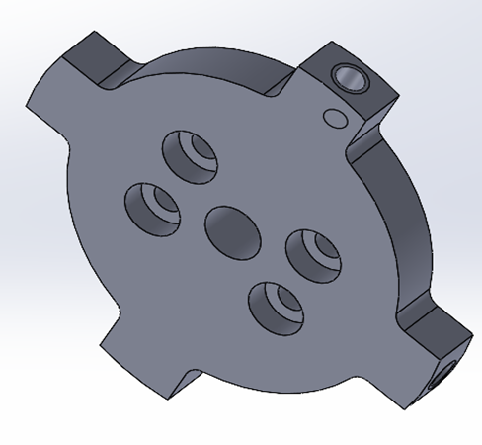

- Nose Cone
The nose cone will be the last part installed on the model. This part is installed by simply screwing it onto the thread of the rotation pin. It is made of Aluminum 6061.
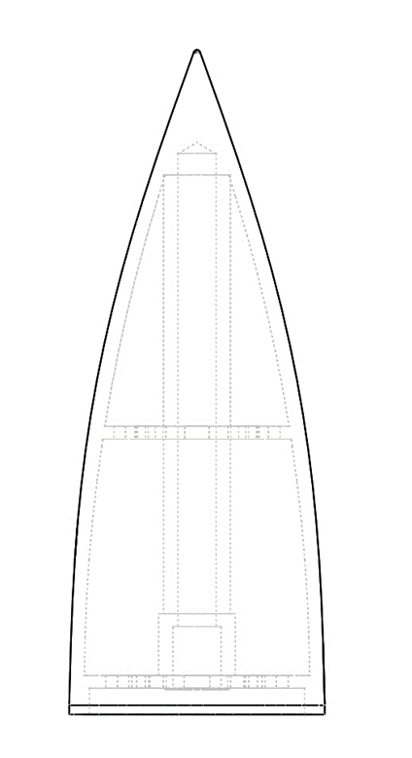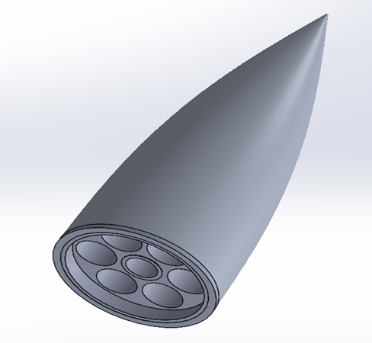
- Sintered Nose Cone Drawing b) Original Nose Cone

- Rear Deflecting Surface
The rear deflecting surface is used to deflect the nose cone of the model. After installation, the flange of this part is covered by both bronze inserts. The part is then placed over the cylindrical protrusion of the frontal motor mount and tightened down.
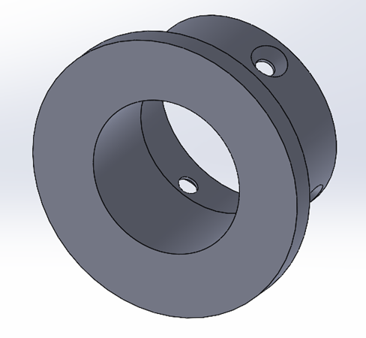
- Rotation Pin
The rotation pin is a unique piece that connects to the universal joint while also threading into the nose cone. This piece must be installed into the bottom of the frontal deflecting surface and then placed in between the bearing. This part must be handled with care due to its rotational aspect.
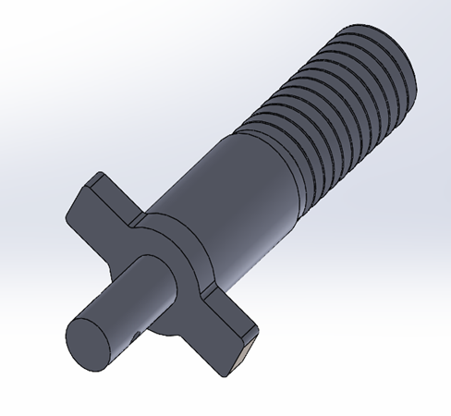
- Sleeve Cuff
The sleeve cuff allows for the mounting of the sleeve around the model and attaches to the cross roller bearing in the nose cone. This allows the skin to stay in line with the back body while the nose rotates around. It must be installed on this bearing before the nose cone is installed on the bearing.
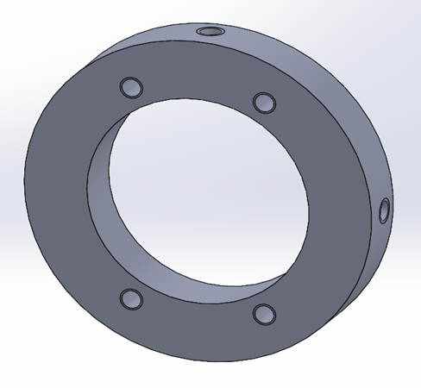
- Universal Joint
The universal joint allows the model to articulate the nose cone. It allows power transmission which enables the nose cone to rotate. It connects to the rotation pin and motor shaft. This part should be installed about the time the deflecting surfaces are attached to one another. It is important that both shafts fit the joint. Finally, a spring pin is then inserted to hold it all in place.
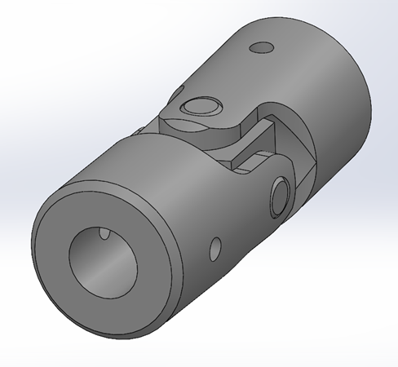

Operation
Before operating the model, it should be mounted properly to avoid damage. There must not be any obstructions to the motion of the fins or nose cone. Once this is ensured and the correct wiring connections are made, the program can be run. The user will be prompted to input the desired deflection angles for both the nose cone and fins. This will run repeatedly until the program is stopped.
Below is the current Arduino code. The code for fin deflection has not been implemented yet, and code for the nose deflection is continuously being updated.
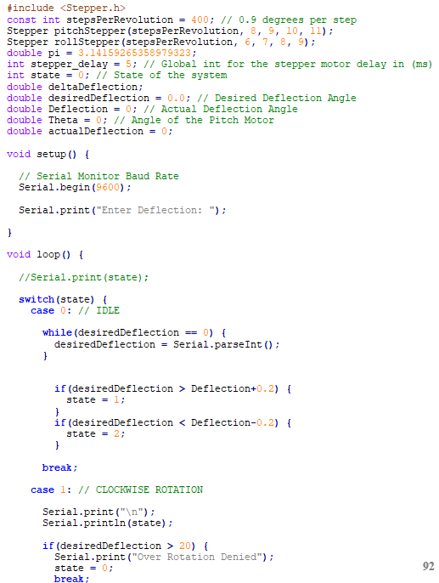

Troubleshooting
Since the projectile body is split into multiple sections, various parts contained within the body can be accessed by disassembling these sections. This makes it easy to adjust any parts if they become loose, as well as repair or replace any parts if need be. For issues with the code, the first solution will be to restart the program. If this doesn’t work, the next step would be to check for errors in the code, and errors in the wiring connections. If issues continue to persist, there are many experienced employees at the College of Engineering and FCAAP who can help.

1.8 Spring Project Plan

Chapter Two: EML 4552C

2.1 Spring Plan

Project Plan.

Build Plan.

Appendices

Appendix A: Code of Conduct
Overview
This document provides an overview of the policies and expectations governing Senior Design Group 509. This document may be amended throughout the semester as the team sees fit. Each member of the team was given input on all sections of the Code of Conduct and have agreed upon them as recognized by the Statement of Understanding.
Mission Statement
To propel projectile system technologies into the future.
Team Roles
The following roles have been created to align with the goals of our project and the specialization of the group members. Each member decided what tasks they were good at performing with regards to team based engineering assignments and chose their role based on that.
If any required actions arise that fall outside of the required duties listed below, member strengths will be reassessed, and the required actions will be appropriately delegated.
Test Engineer – Jack Corbin
The test engineer will determine how to create a process that would best test components or systems to ensure the quality and functionality of the product. The test engineer will work with the research engineer and will oversee functions such as writing test plans, conducting quality assurance, and designing performance tests, and troubleshooting any errors and streamlining the testing procedures.
Field Engineer – Emily Groth
The field engineer will be responsible for providing support with the experimentation and testing of the project. The field engineer will also be responsible for looking for possible sources of error in measurements made, as well as being responsible for taking the proper safety measures.
Design Engineer – Deepkumar Patel
Design engineer is responsible for the identification of complex design problems and anticipating production issues. The design engineer will develop innovative design solutions, evaluate options, conduct tests, and implement solutions to meet timing, product cost and reliability targets. The design engineer will work with the systems engineer to integrate these subsystems into the major system.
Systems Engineer – Aaron Weingarten
The systems engineer will be responsible for the development of subsystems and integration of these subsystems into the major system. The systems engineer will also regulate or solve all compatibility issues or data translation between systems. The systems engineer is expected to focus on modularity of subsystems as well as the interconnection between them.
Research Engineer – Prosley Dorcely
The research engineer will be responsible for investigating new methods throughout product ideation and will be considered responsible for finding what has previously been accomplished related to the project goal. The research engineer will also be responsible for determining the necessary test to validate potential prototypes and whether the prototypes perform to expectations. The research engineer will also be responsible for making sure that all assignments and required actions such as emails are submitted/sent by their required time.
Communication
Communications will be split between Microsoft Teams and emails. All forms of communication are open for change if discussed by the group.
Microsoft Teams
For all official communication and scheduling within the group, teams will be used. This includes:
- Virtual meetings
- Weekly assignment
- All file transfer and updates on task completion
- Notice of absence (see Attendance Policy)
Every assignment or significant progress update will require being send and approved by the group before submitting.
Emails
For all official communication and scheduling, university emails will be used. This includes:
- Communication with Sponsor/Advisor
- Communication with Dr. McConomy
- Communications with TAs
Email will be delivered using outlook. This policy exists such that a timestamped record will be available to all group members covering the transfer and updates of all important items relating to the project. Group members are expected to respond to emails within 3 days.
Texting
Texting will be used as the method for informal communication such as quick updates, questions/discussions within the team, etc. These are defined as anything that needs to be communicated but does not have considerable weight governing the outcome of the answer. Group members are expected to respond to texts within 24 hours.
Dress Code
Dress Code will depend on the event that is taking place. For an informal team meeting, the only dress code required will be non-offensive clothing. Formal meetings with the project sponsor/advisor will require a business casual dress code consisting of khakis and a polo shirt of neutral color. Lastly, presentations will require a business formal dress code consisting of a jacket and dress pants.
Attendance Policy
Attendance to formal meetings with advisors/sponsors and meetings discussing Design Reviews are required unless the absence is excused by the team member’s university. For informal team meetings, if a team member can’t attend, a one-week notice must be provided. If the meeting that the team member misses have to be rescheduled, that team member is responsible for doing so.
Outside Obligations
All members of the group are to put their class schedule in the group calendar to determine availability for group meetings.
Group Members | Obligations
Deepkumar Patel | No outside commitments.
Emily Groth | Works Friday and Sunday from 3-9pm (can be rescheduled for important milestones). Work at Alvi’s lab – 10hr/week (flexible). Work as a TA 20hr/week.
Prosley Dorcely | No outside commitments
Jack Corbin | No outside commitments
Aaron Weingarten | No outside commitments

Group Notification
Group Notification for absence/attendance will be done via Microsoft Teams. If a team member fails to notify the group, the Strike System will be implemented.
Professional Meeting Response Guideline
The following guideline will be used for professional meetings:
- Listen to others talk professionally
- Incorporate business phrases
- Stop using slang and filler words
- Pay attention to tone and inflection
- Seek honest feedback on your speaking
Strike System
Strikes are given to team members under one of two conditions. If the team is not notified of an absence or the absence is not permitted for a specific meeting or presentation, then the absentee is given a strike. Strikes can also be given if a team member fails to communicate with the team for periods longer than a week apart from predetermined periods such as winter holiday, work trip, school event, etc. Strikes are voted upon and require a majority vote. At the first strike the team member at fault receives a verbal warning as well as a chance to defend their absence. The first strike serves as a warning with no consequences to grade or team standing. After the second strike, Dr. McConomy is contacted and a reduction in grade is suggested.
Amend
For any amendments to the code of conduct, a majority vote must first take place. With three out of the four members voting in favor of any amendment, the code of conduct may be altered to solidify any changes the group may make. An amendment may be proposed and voted upon at any time during the project’s duration.
Amendments

Statement of Understanding
I have read and understand this team’s code of conduct and agree to follow it to the best of my abilities. I hold myself responsible for being a valuable and productive team member.
Signatures:
Name | Signature
Deepkumar Patel | Deepkumar
Emily Groth | 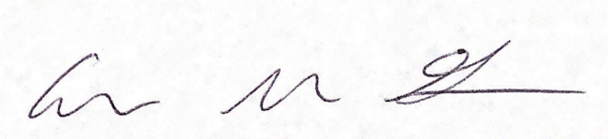  Emily Groth 09-09-2022
Jack Corbin | Jack Corbin 09-09-2022
Aaron Weingarten | 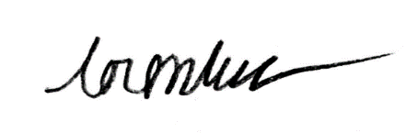  Aaron Weingarten 09-09-2022
Prosley Dorcely | 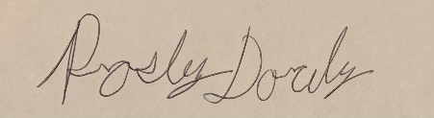  Prosley Dorcely 09-09-2022

Date: 09/09/2022

Appendix B: Functional Decomposition

Appendix C: Target Catalog
System | Function | Target | Metric
Nose Actuation | Control Deflection | ±5° | Angular position
Control | Take User Input | ≤ 6 Milliseconds | Time
Control | Provide Linear Output for Nose Deflection | 1 Degree/Volt | Degrees per Volt
Control | Provide Fin Output | ≤ 6 Milliseconds | Time
Structure | Maintains Integrity | Nose Cone Performance at ≤ 10 lbs. | Force
Structure | Secure Components | Displacement of Parts ≤ 0.0625 Inches | Distance
Structure | Attach to Supports | Disassembled Supports = 0 | Number of Supports
Structure |  | L/D = 8, 12, 16 | Length to diameter ratio
Nose Actuation |  | Nose Time Constant ≤ 0.5 sec | Time
Structure |  | Projectile Model Weight ≤ 100 lbs. | Weight
Fin Actuation |  | Fins Time Constant ≤ 0.5  Sec | Time
Structure |  | Test Time ≥ 45 Min | Time

Appendix D: Work Break Down
Project Name | "Smart" Projectile
Project Manager | Dr. Kumar
Company Name | FCAAP
Semester | Fall 2022
Milestones | Task | Subtasks | Assigned | Due Date
Project Scope
 | Meeting
 |  | Schedule a Meeting | Aaron Weingarten
 |  | Attend Meeting Concerning Project Objective | Everyone
 | Assignment
 |  | Interpret Information from Meeting | Everyone
 |  | Construct Document Containing Project Scope | Deepkumar Patel
 |  | Identify Project Description, and Key Goals | Prosley Dorcely
 |  | Identify Markets, Assumptions and Stakeholder | Jack Corbin
 |  | Review Assignment | Everyone
 |  | Update Sponsor/Advisor with the results | Aaron Weingarten
 | Submit To Canvas |  | Deepkumar Patel | 9/23/2022
Research
 | Background Information
 |  | Analyze Background Articles Provided by Sponsor/Advisor | Emily Groth
 |  | Research Motors and Motor Controllers | Prosley Dorcely
 |  | Research Materials | Deepkumar Patel
 |  | Research Propulsion | Prosley Dorcely
 |  | Research any Existing Products | Jack Corbin
 |  | Research Aerodynamics and Deflection | Aaron Weingarten
Customer Needs
 | Meeting
 |  | Schedule a Meeting | Aaron Weingarten
 |  | Attend Meeting Concerning Customer's Needs | Everyone
 | Assignment
 |  | Write Down Customer Needs | Emily Groth
 |  | Set Up Chart Containing Recorded Needs Vs. Interpreted Needs | Deepkumar Patel
 |  | Construct Document Containing Customer Needs | Aaron Weingarten
 |  | Review Assignment | Everyone
 |  | Update Sponsor/Advisor with the results | Aaron Weingarten
 | Submit To Canvas |  | Deepkumar Patel | 9/30/2022
Functional Decomposition
 | Meeting
 |  | Schedule a Meeting | Aaron Weingarten
 |  | Attend Meeting Concerning the Different Functions | Everyone
 | Assignment
 |  | Construct Fundamental Functions for our Project | Jack Corbin
 |  | Prioritize Based on Importance using Hierarchy Chart | Emily Groth
 |  | Create Function Structure | Prosley Dorcely
 |  | Update Sponsor/Advisor with the results | Aaron Weingarten
 | Submit To Canvas |  | Deepkumar Patel | 10/7/2022
VDR 1
 | Meeting
 |  | Schedule a Meeting | Aaron Weingarten
 |  | Attend Meeting Concerning VDR 1 | Everyone
 |  | Work on Powerpoint | Everyone
 | Submit Draft VDR 1 |  | Deepkumar Patel | 10/14/2022
 |  | Make Correction on Feedback | Everyone
 | Final Submission VDR 1 |  | Deepkumar Patel | 10/18/2022
 | Presentation |  | Everyone
Targets
 | Meeting
 |  | Schedule a Meeting | Aaron Weingarten
 |  | Attend Meeting Concerning Targets | Everyone
 |  | Research Validation Techniques | Emily Groth
 |  | Benchmarking Targets | Deepkumar Patel
 | Assignment
 |  | Derivation of Target | Jack Corbin
 |  | Discussion of Measurements | Prosley Dorcely
 |  | Critical Targets/Metrics | Aaron Weingarten
 |  | Review Assignment | Everyone
 | Submit To Canvas |  | Deepkumar Patel | 10/28/2022
Concept Generation
 | Meeting
 |  | Schedule a Meeting | Aaron Weingarten
 |  | Attend Meeting Concerning Concept Generation | Everyone
 |  | Brainstorm 100 Concepts | Everyone
 | Assignment
 |  | Create sketches | Emily Groth
 |  | Select Medium and High Fidelity Concepts | Prosley Dorcely
 |  | Create Charts | Jack Corbin
 |  | Review Assignment | Everyone
 | Submit To Canvas |  | Deepkumar Patel | 11/4/2022
Concept Selection
 | Meeting
 |  | Schedule a Meeting | Aaron Weingarten
 |  | Attend Meeting Concerning Concept Selection | Everyone
 |  | Establish Customer Requirements | Emily Groth
 |  | Binary Pairwise Comparison | Deepkumar Patel
 | Assignment
 |  | House of Quality | Jack Corbin
 |  | Pugh Chart | Prosley Dorcely
 |  | Analytical Hierarchy Chart | Deepkumar Patel
 |  | Consistency Check | Aaron Weingarten
 |  | Final Rating Matrix | Prosley Dorcely
 |  | Review Assignment | Everyone
 |  | Update Sponsor/Advisor with the results | Aaron Weingarten
 | Submit To Canvas |  | Deepkumar Patel | 11/4/2022
Risk Assessment
 | Meeting
 |  | Schedule a Meeting | Aaron Weingarten
 |  | Attend Meeting Concerning Risk Assessment | Everyone
 |  | Identify Hazards | Prosley Dorcely
 |  | Research of Safety Hazards | Jack Corbin
 | Assignment
 |  | Steps to Avoid Hazards | Emily Groth
 |  | Safety Measures | Deepkumar Patel
 |  | Complete risk assessment forms | Aaron Weingarten
 |  | Review Assignment | Everyone
 | Submit To Canvas |  | Deepkumar Patel | 11/18/2022
Bill Of Materials
 | Meeting
 |  | Schedule a Meeting | Aaron Weingarten
 |  | Attend Meeting Concerning Bill of Materials | Everyone
 |  | Research Material Selection | Jack Corbin
 |  | Labor Costs | Prosley Dorcely
 | Assignment
 |  | Compile List of Parts | Emily Groth
 |  | Identify Vendors | Jack Corbin
 |  | Outline Costs | Prosley Dorcely
 |  | Review Assignment | Everyone
 | Submit To Canvas |  | Deepkumar Patel | 11/28/2022
Physical Model
 | Meeting
 |  | Schedule a Meeting | Aaron Weingarten
 |  | Attend Meeting Concerning Physical Model | Everyone
 | Assignment
 |  | CAD Drawings | Deepkumar Patel
 |  | Cost Analysis | Emily Groth
 |  | 3D Printing | Prosley Dorcely
 |  | Prototype Assembly | Aaron Weingarten
 |  | Scaling and measurements | Jack Corbin
 |  | Update Sponsor/Advisor with the results | Aaron Weingarten
Spring Project Plan
 | Meeting
 |  | Schedule a Meeting | Aaron Weingarten
 |  | Schedule Meeting with Sponsor/Advisor | Aaron Weingarten
 |  | Identify Milestones and Timeline | Everyone
 | Assignment
 |  | Establish Milestones | Prosley Dorcely
 |  | Determine Deliverables | Jack Corbin
 |  | Review Assignment | Everyone
 | Submit To Canvas |  | Deepkumar Patel | 12/2/2022

Appendix E: Concept Generation and Morphological Chart
Concept Generation
Brainstorming
- Smart projectile has magnetized nose cone that alters flight path
- Smart projectile ejects a device that grabs onto the target to alter flight path
- Smart projectile has an interior pulley system that deflects the nose cone to alter flight path
- Smart projectile uses an exterior pulley system that deflects the nose cone to alter flight path
- Smart projectile uses an interior mass that moves nose cone into direction of target to alter flight path
- Smart projectile uses exterior mass that moves nose cone into direction of target to alter flight path
- Smart projectile uses static fins to control flight path
- Smart projectile uses dynamically deflectable fins to control flight
- Smart projectile uses solar powered fins to control flight path
- Smart projectile uses jets to control fins and thus flight path
- Smart projectile uses jets to control the nose cone and thus the flight path
- Smart projectile has actuating flaps that can alter flow and thus flight path
- Smart projectile uses a tracking device that allows it to find the target and thus alter flight path
- Smart projectile uses a special skin material that allows it to find the target and alter flight path
- Smart projectile ejects a pre-missile that shows it how to find the target and alter flight path
- Smart projectile has a sensing device that locates other devices in air which finds the target and alters flight path
- Smart projectile uses deployable parachutes as fins to alter flight path into direction of target and alters flight path
- Smart projectile uses a nose cone with an exterior built-in radar that allows it to find the target and alter flight path
- Smart projectile uses a nose cone with an interior built-in radar that allows it to find the target and alter flight path
- Smart projectile uses a fixed dimensioned fin to allow it to find the target and alter flight path
- Smart projectile uses a multi-shape fin which can be altered to allow it to find the target and change flight path
- Smart projectile senses change in aerodynamic forces around it and alter its flight path
- Smart projectile has extendable wings to provide control and alter flight path
- Smart projectile uses static thrusters to change flight path
- Smart projectile uses deflectable thrusters to change flight path
- Smart projectile has deflectable propeller to change flight path
- Smart projectile has static propeller to change flight path
- Smart projectile uses radar to detect the target and alter the flight path
- Smart projectile launches grappling hook once in range of target to alter the flight path
- Smart projectile flies over target and drops payload to alter flight path
- Smart projectile flies under target and shoots an additional profile up to alter flight path
- Smart projectile uses articulating nose cone and dynamically deflectable fins for flight control
- Smart projectile uses recoil from firing bullets to alter flight path
- Smart projectile uses sails to provide control and alter flight path
- Smart projectile uses extendable nose cone to change location of center of mass to aid flight path
- Smart projectile uses internal gyroscope to sense position and aid flight path
- Smart projectile is filled with substance before flight that is then emitted to influence flight path
- Smart projectile tracks the heat signature of target to alter flight path
- Smart projectile uses expandable nose cone to change velocity and thus flight path
- Smart projectile shoots payload at target once in range to aid in flight path
- Smart projectile can alter flight path by absorbing atmospheric gases to change its mass
- Smart projectile uses rudder to change direction and thus aids flight path
- Smart projectile has miniature turbines to control flight path
- Smart projectile uses springs to obtain linear motion to alter in flight path
- Dynamics fins use thrusters for deflection to alter flight path
- Smart projectile uses a light material than aluminum for deflection to influence flight path
- Smart projectile uses a DC motor for controls to alter flight path
- Dynamic fins use a servo motor for controls to alter flight path
- Nose cone uses a servo motor to for controls to change flight path
- Smart projectile rapidly ejects and retracts internal mass to change flight path
- Smart projectile uses deflectable vents to redirect flow
- Smart projectile can bend its shape to alter flight path
- Nose cone can open and close to change force of flow on projectile
- Smart projectile can perform flips during flight to alter flight path
- Smart projectile uses an internal mass for mechanical control to alter flight path
- Smart projectile uses microcontroller to control the movement of nose and fins
- Smart projectile uses rotating tail fins to generate lift when flow is detached
- Smart projectile with elliptical dynamic fins to reduce drag
- Smart projectile with swept-tapered fins for mechanical control
- Dynamic fins using AI to adapt to any unforeseen circumstances
- Smart projectile uses morphing fins that can widen and thin out depending on the forces they are trying to exert
- Dynamics fins using morphing fuselage that can adapt its shape to allow better flow around it
- Smart projectile uses infrared technology to track and change direction
- Smart projectile using toray t300 frame for additional strength to aid in flight path
- Smart projectile using toray t700 frame for additional strength to aid in flight path
- Smart projectile using toray t800 frame for additional strength to aid in flight path
- Smart projectile using toray t1100 frame for additional strength to aid in flight path
- Dynamic fins made of fiber material to control movement
- Smart projectile using a morphing nose that could flatten to provide more lift surface
- Smart projectile using an aerodynamic surface(strakes) to the articulating part of the nose
- Smart projectile uses robotic arm inside body moves articulating nose cone
- Smart projectile uses a cruciform placement for dynamic fins
- Smart projectile uses a X configuration placement for dynamic fins
- Smart projectile uses thrust vectoring nozzles to articulate the nose cone to a desired deflection
- Smart projectile uses raspberry pie computer to control the nose cone
- Smart projectile uses different power sources to alter flight path
- Smart projectile uses motors with greater current ratings
- Smart projectile uses internal rails to force nose cone to move in a linear fashion
- Smart projectile uses electromagnetic system to articulate the nose cone and fins
- Smart projectile utilizes laser guidance as controls to alter flight path
- Smart projectile uses a PlayStation controller as controls to alter flight path
- Smart projectile uses an Xbox controller as controls to alter flight path
- Smart projectile uses a Nintendo controller as controls to alter flight path
- Smart projectile uses wireless inputs from the controller to alter flight path
- Smart projectile uses controllable external mass that can move around the body and change the aerodynamic characteristics
- Smart projectile that changes the center of mass with eject-able mass
- Smart projectile uses air permeable materials for zero drag and relies purely on thrust
- Smart projectile has openable air ducts to reroute flow around it
- Smart projectile aborts mission and return to sender for hazardous environment to better mission plan
- Smart projectile uses solar energy to provide actuation for nose cone
- Smart projectile uses movable fins to control flight path
Biomimicry
- Smart projectile using head of bird of prey for the nose cone
- Smart projectile with exoskeleton fins for extra protection
- Smart projectile uses bird-like wings that can flap to control flight path
- Smart projectile has extendable arms that control the deflection of nose cone which finds the target and alters flight path
- Smart projectile ejects a substance like a spitting cobra in the direction it wants the nose cone to deflect thus finding the target and altering flight path
Morphological methods
- Smart projectile with dynamic fins that uses combustion to control nose articulation
- Smart projectile that controls flow using piezoelectric flaps and dynamic fins for mechanical control
- Smart projectile that uses deflecting flaps for mechanical control and vortex generators for flow control
100. Smart projectile uses drag panels for mechanical control for nose and pulsating jets for flow control
Morphological Chart
Table: Morphological Chart
Flow Control | Mechanical Control
Piezoelectric Flaps | Dynamic fins
Pulsating Jets | Deflecting Flaps
Combustion | Drag panels
Vortex generators

Appendix F: Binary Pairwise Comparison
Table: Binary Pairwise Comparison
Customer Needs | Nose cone deflection of up to 5 degrees with error of ±0.1 degrees | Fins that are statically or dynamically deflectable | Projectile can withstand wind up to 30 m/s | Nose  moves in straight line to desired position in 0.5 seconds or less | Light-weight material | Sum
Nose cone deflection of up to 5 degrees with error of ±0.1 degrees | -- | 1 | 1 | 1 | 1 | 4
Fins that are statically or dynamically deflectable | 0 | -- | 1 | 1 | 1 | 3
Projectile can withstand wind up to 30 m/s | 0 | 0 | -- | 0 | 1 | 1
Nose moves in straight line to desired position in 0.5 seconds or less | 0 | 0 | 1 | -- | 1 | 2
Light-weight material | 0 | 0 | 0 | 0 | -- | 0
Sum | 0 | 1 | 3 | 2 | 4 | n – 1 = 4

Appendix G: House of Quality
Table: House of Quality
Improvement Direction |  | ↑ | ↓ | ↓ | ↑ | ↓ | ↓
Units |  | Angular position (deg) | Time (ms) | Time (ms) | Force (lbs) | Distance (in) | Number of detached supports
Customer Requirements | Importance Weight Factor | Controls Nose Deflection | Takes User Input | Provides Output for Fins | Maintains Rigidity | Secures components | Attaches to supports
Nose cone deflection of up to 5 degrees with error of ±0.1 degrees | 4 | 9 | 1
Fins that are statically or dynamically deflectable | 3 |  | 3 | 9 |  |  | 1
Projectile can withstand wind up to 30 m/s | 1 |  |  |  | 9 | 3 | 3
Nose moves in straight line to desired position in 0.5 seconds or less | 2 | 9 | 3
Lightweight Material | 0 |  |  |  | 9 | 9 | 1
Raw Score (132) |  | 54 | 19 | 27 | 9 | 3 | 6
Relative Weight |  | 40.91 | 14.39 | 20.45 | 6.82 | 2.27 | 4.55
Rank Order |  | 1 | 3 | 2 | 4 | 6 | 5

Appendix H: Pugh Chart
Table: Initial Pugh Chart
Pugh Chart
Function |  | Concept
 |  | #3 | #23 | #59 | #69 | #83 | #27 | #34 | #53
Controls nose deflection | Datum (Basic Body with fin deflection) | + | S | S | S | + | S | + | S
Takes user input |  | S | S | S | S | S | S | S | S
Provides output for fins |  | - | - | - | S | - | - | S | -
Maintains rigidity |  | S | S | - | S | S | S | S | S
Secures components |  | - | S | - | S | S | S | S | S
Attaches to supports |  | - | S | - | - | - | - | S | -
 | Plus (+) | 1 | 0 | 0 | 0 | 1 | 0 | 1 | 0
 | Satisfactory (S) | 2 | 5 | 2 | 5 | 3 | 4 | 5 | 4
 | Minus (-) | 3 | 1 | 4 | 1 | 2 | 2 | 0 | 2

Table: Second Pugh Chart
Pugh Chart
Function |  | Concept
 |  | #3 | #69 | #83 | #27 | #34 | #53
Controls nose deflection | Datum (Concept 23) | + | S | + | S | + | S
Takes user input |  | S | S | S | S | S | S
Provides output for fins |  | - | S | - | - | S | -
Maintains rigidity |  | S | S | S | S | S | S
Secures components |  | - | S | S | S | S | -
Attaches to supports |  | S | - | S | - | S | -
 | Plus (+) | 1 | 0 | 1 | 0 | 1 | 0
 | Satisfactory (S) | 3 | 5 | 4 | 4 | 5 | 3
 | Minus (-) | 2 | 1 | 1 | 2 | 0 | 3

Table: Final Pugh Chart
Pugh Chart
 |  | Concept
Function |  | #3 | #27 | #34 | #83
Controls nose deflection | Datum (Concept 69) | + | S | + | +
Takes user input |  | S | S | S | S
Provides output for fins |  | - | - | S | -
Maintains rigidity |  | S | S | S | S
Secures components |  | - | S | S | S
Attaches to supports |  | S | - | + | +
 | Plus (+) | 1 | 1 | 2 | 2
 | Satisfactory (S) | 3 | 2 | 4 | 3
 | Minus (-) | 2 | 3 | 0 | 1

Appendix I: Analytical Hierarchy Process
Table : Analytical Hierarchy Process
Analytical Hierarchy Process
Criteria | Controls nose deflection | Takes user input | Provides output for fins | Maintains rigidity | Secures components | Attaches to supports
Controls nose deflection | 1.000 | 1.000 | 0.333 | 0.333 | 0.333 | 0.333
Takes user input | 1.000 | 1.000 | 0.333 | 0.200 | 0.333 | 0.333
Provides output for fins | 3.000 | 3.000 | 1.000 | 0.333 | 0.333 | 0.333
Maintains rigidity | 3.000 | 5.000 | 3.000 | 1.000 | 1.000 | 1.000
Secures components | 3.000 | 3.000 | 3.000 | 1.000 | 1.000 | 1.000
Attaches to supports | 3.000 | 3.000 | 3.000 | 1.000 | 1.000 | 1.000
SUM | 14.000 | 16.000 | 10.667 | 3.867 | 4.000 | 4.000

Table : Normalized Criteria Comparison Matrix
Normalized Criteria Comparison Matrix
Criteria | Controls nose deflection | Takes user input | Provides output for fins | Maintains rigidity | Secures components | Attaches to supports | Criteria Weight {W}
Controls nose deflection | 0.072 | 0.063 | 0.031 | 0.086 | 0.083 | 0.083 | 0.070
Takes user input | 0.072 | 0.063 | 0.031 | 0.051 | 0.083 | 0.083 | 0.064
Provides output for fins | 0.214 | 0.187 | 0.095 | 0.086 | 0.083 | 0.083 | 0.125
Maintains rigidity | 0.214 | 0.313 | 0.281 | 0.259 | 0.250 | 0.250 | 0.261
Secures components | 0.214 | 0.187 | 0.281 | 0.259 | 0.250 | 0.250 | 0.240
Attaches to supports | 0.214 | 0.187 | 0.281 | 0.259 | 0.250 | 0.250 | 0.240
SUM | 1.000 | 1.000 | 1.000 | 1.000 | 1.000 | 1.000 | 1.000

Table: Consistency Check
Consistency Check
{Ws}={C}{W} | {W} |  | Cons={Ws}./{W}
Weighted Sum Vector | Criteria Weights |  | Consistency Vector
1.764 | 0.294 |  | 6.000
1.764 | 0.294 |  | 6.000
1.092 | 0.182 |  | 6.000
0.254 | 0.042 |  | 6.048
0.564 | 0.094 |  | 6.000
0.564 | 0.094 |  | 6.000
Average Consistency (λ): |  | 6.008
Consistency Index (CI): |  | 0.0016
Consistency Ratio (CR): |  | 0.001

Table: Controls Nose Deflection Comparison
Controls Nose Deflection Comparison [C]
 |  | Design #3: |  | Design #34: |  | Design #83:
Design #3: |  | 1.000 |  | 0.333 |  | 3.000
Design #34: |  | 3.000 |  | 1.000 |  | 3.000
Design #83: |  | 0.333 |  | 0.333 |  | 1.000
SUM: |  | 4.333 |  | 1.666 |  | 7.000
Normalized Controls Nose Deflection Comparison [NormC]
 |  | Design #3: | Design #34: |  | Design #83: | D.A.P {Pi}
Design #3: |  | 0.231 | 0.200 |  | 0.429 | 0.287
Design #34: |  | 0.692 | 0.600 |  | 0.429 | 0.574
Design #83: |  | 0.077 | 0.200 |  | 0.142 | 0.140
SUM: |  | 1.000 | 1.000 |  | 1.000 | 1.000
Consistency Check
{Ws}={C}{Pi} | {Pi} | Cons={Ws}./{Pi}
Weighted Sum Vector | Criteria Weights | Consistency Vector
0.860 | 0.287 | 2.997
1.721 | 0.574 | 2.998
0.419 | 0.140 | 2.993

Table: Takes User Input Comparison
Takes User Input Comparison [C]
 |  | Design #3: |  | Design #34: |  | Design #83:
Design #3: |  | 1.000 |  | 1.000 |  | 1.000
Design #34: |  | 1.000 |  | 1.000 |  | 1.000
Design #83: |  | 1.000 |  | 1.000 |  | 1.000
SUM: |  | 3.000 |  | 3.000 |  | 3.000
Normalized Takes User Input Comparison [NormC]
 |  | Design #3: | Design #34: |  | Design #83: | D.A.P {Pi}
Design #3: |  | 0.333 | 0.333 |  | 0.333 | 0.333
Design #34: |  | 0.333 | 0.333 |  | 0.333 | 0.333
Design #83: |  | 0.333 | 0.333 |  | 0.333 | 0.333
SUM: |  | 1.000 | 1.000 |  | 1.000 | 1.000
Consistency Check
{Ws}={C}{Pi} | {Pi} | Cons={Ws}./{Pi}
Weighted Sum Vector | Criteria Weights | Consistency Vector
1.000 | 0.333 | 3.000
1.000 | 0.333 | 3.000
1.000 | 0.333 | 3.000

Table: Provides Output for Fins Comparison
Provides Output for Fins Comparison [C]
 |  | Design #3: |  | Design #34: |  | Design #83:
Design #3: |  | 1.000 |  | 0.143 |  | 1.000
Design #34: |  | 7.000 |  | 1.000 |  | 7.000
Design #83: |  | 1.000 |  | 1.000 |  | 1.000
SUM: |  | 9.000 |  | 2.143 |  | 9.000
Normalized Provides Output for Fins Comparison [NormC]
 |  | Design #3: | Design #34: |  | Design #83: | D.A.P {Pi}
Design #3: |  | 0.111 | 0.067 |  | 0.111 | 0.096
Design #34: |  | 0.778 | 0.467 |  | 0.778 | 0.674
Design #83: |  | 0.111 | 0.467 |  | 0.111 | 0.230
SUM: |  | 1.000 | 1.000 |  | 1.000 | 1.000
Consistency Check
{Ws}={C}{Pi} | {Pi} | Cons={Ws}./{Pi}
Weighted Sum Vector | Criteria Weights | Consistency Vector
0.289 | 0.096 | 3.010
2.023 | 0.674 | 3.001
0.689 | 0.230 | 2.996

Table: Maintains Rigidity Comparison
Maintains Rigidity Comparison [C]
 |  | Design #3: |  | Design #34: |  | Design #83:
Design #3: |  | 1.000 |  | 1.000 |  | 1.000
Design #34: |  | 1.000 |  | 1.000 |  | 1.000
Design #83: |  | 1.000 |  | 1.000 |  | 1.000
SUM: |  | 3.000 |  | 3.000 |  | 3.000
Normalized Maintains Rigidity Comparison [NormC]
 |  | Design #3: | Design #34: |  | Design #83: | D.A.P {Pi}
Design #3: |  | 0.333 | 0.333 |  | 0.333 | 0.333
Design #34: |  | 0.333 | 0.333 |  | 0.333 | 0.333
Design #83: |  | 0.333 | 0.333 |  | 0.333 | 0.333
SUM: |  | 1.000 | 1.000 |  | 1.000 | 1.000
Consistency Check
{Ws}={C}{Pi} | {Pi} | Cons={Ws}./{Pi}
Weighted Sum Vector | Criteria Weights | Consistency Vector
1.000 | 0.333 | 3.000
1.000 | 0.333 | 3.000
1.000 | 0.333 | 3.000

Table: Secures Components Comparison
Secures Components Comparison [C]
 |  | Design #3: |  | Design #34: |  | Design #83:
Design #3: |  | 1.000 |  | 0.333 |  | 0.333
Design #34: |  | 3.000 |  | 1.000 |  | 1.000
Design #83: |  | 3.000 |  | 1.000 |  | 1.000
SUM: |  | 7.000 |  | 2.333 |  | 2.333
Normalized Secures Components Comparison [NormC]
 |  | Design #3: | Design #34: |  | Design #83: | D.A.P {Pi}
Design #3: |  | 0.143 | 0.143 |  | 0.143 | 0.143
Design #34: |  | 0.429 | 0.429 |  | 0.429 | 0.429
Design #83: |  | 0.429 | 0.429 |  | 0.429 | 0.429
SUM: |  | 1.000 | 1.000 |  | 1.000 | 1.000
Consistency Check
{Ws}={C}{Pi} | {Pi} | Cons={Ws}./{Pi}
Weighted Sum Vector | Criteria Weights | Consistency Vector
0.429 | 0.143 | 3.000
1.287 | 0.429 | 3.000
1.287 | 0.429 | 3.000

Table: Attaches to Supports Comparison
Attaches to Supports Comparison [C]
 |  | Design #3: |  | Design #34: |  | Design #83:
Design #3: |  | 1.000 |  | 1.000 |  | 1.000
Design #34: |  | 1.000 |  | 1.000 |  | 1.000
Design #83: |  | 1.000 |  | 1.000 |  | 1.000
SUM: |  | 3.000 |  | 3.000 |  | 3.000
Normalized Attaches to Supports Comparison [NormC]
 |  | Design #3: | Design #34: |  | Design #83: | D.A.P {Pi}
Design #3: |  | 0.333 | 0.333 |  | 0.333 | 0.333
Design #34: |  | 0.333 | 0.333 |  | 0.333 | 0.333
Design #83: |  | 0.333 | 0.333 |  | 0.333 | 0.333
SUM: |  | 1.000 | 1.000 |  | 1.000 | 1.000
Consistency Check
{Ws}={C}{Pi} | {Pi} | Cons={Ws}./{Pi}
Weighted Sum Vector | Criteria Weights | Consistency Vector
1.000 | 0.333 | 3.000
1.000 | 0.333 | 3.000
1.000 | 0.333 | 3.000

Table: Final Rating Comparison
Final Rating Comparison
Selection Criteria | Design #3: | Design #34: | Design #83:
Controls Nose Deflection | 0.287 | 0.574 | 0.140
Takes User Input | 0.333 | 0.333 | 0.333
Provides Output for Fins | 0.096 | 0.674 | 0.230
Maintains Rigidity | 0.333 | 0.333 | 0.333
Secures Components | 0.143 | 0.429 | 0.429
Attaches to Supports | 0.333 | 0.333 | 0.333

Table: Concept Selection
Concept | Alternative Value
Smart projectile has an interior pulley system that deflects the nose cone to alter flight path | 0.258482
Smart projectile uses articulating nose cone and dynamically deflectable fins for flight control | 0.47494
Smart projectile uses thrust vectoring nozzles to articulate the nose cone to a desired deflection | 0.266536

Appendix J: Operation Manual
Overview
The Florida Center for Advanced Aero-Propulsion (FCAAP) plans to further its research of an articulating nose cone for missile flight control. By articulating the nose cone of a projectile, a pressure difference is created which causes a change in its direction during flight. Currently, operational missile technologies only involve fins and canards for flight control. With the implementation of an articulating nose cone, its effects on aerodynamics will be studied via testing in the low-speed wind tunnel at FCAAP. This will be tested in combination with deflectable fins.
Project Objective
The objective of this project is to create a scale model of a projectile with an articulating nose cone and deflectable fins for subsonic wind tunnel testing.
Key Goals
There are a few main goals that will try to be achieved upon the completion of this project.
- The nose cone will reach a range of ± 5° of deflection after the linear motion is accounted for.
- The fins will reach a range of ± 30 ° of deflection
- The time constant for the nose cone and fins will be no more than 0.5 seconds.
Components/Integration
Listed below are the steps of how to assemble the projectile and a detailed description of each component and the role they play in the model.
- Back Body
The back body is the rearmost portion of the projectile body. This is where the fins are attached and where the mechanism to operate the fins is contained. The motors are contained within a motor housing, and the gears are configured perpendicular to each other. The gears that are connected to the fins are held in place by a flared base at the end of each fin shaft.
- Miter Gears
The miter gears are made of nylon plastic and have an outer diameter of 0.4 inches, and a pitch diameter of 0.375 inches. They are used in the motor configuration in the back body.
- Fin shaft
Four steel shafts are used, one for each fin. Each shaft is inserted into a hole in the fin, with its opposite end inserted into a miter gear. This miter gear is contained within the back body.

- Servo Motor
Four sub-micro servo motors are placed in the back body to operate the fins. Each motor is aligned with its axis of rotation directed parallel to the projectile body. They each rotate a configuration of 2 miter gears, which outputs motion to each fin.

- Servo Motor Housing
A 3D printed insert is used to hold servo motors and gears in place to keep the gears, servo, and shaft connections in alignment from with one another. There is a 0.505-inch diameter hole in the center of the insert to fit the supporting rod and two other 0.89-inch holes to fit the servo motors into the insert.
- Supporting Rod
The rod is placed in the center of the projectile body and runs along its entire length. It extends beyond the back of the projectile to allow mounting during wind tunnel testing. It is 0.5 inches in diameter.
- Fins
There are four fins, all placed on the back body of the projectile. They are aligned symmetrically, with each fin placed 90 degrees from one another. Each fin is 2 inches in length and 0.14 inches thick at its thickest section. A hole is drilled into each fin with a shaft inserted inside to attach to the model. They are made of Aluminum 6061.
- Middle Outer Body
The middle outer body contains several parts including the long shaft motor, back motor mount, and cross roller bearing. This component holds the rolling mechanism of the assembly and mounts on the force balance to gather data from testing. This part is made from Aluminum 6061.

- Back Motor Mount
The back motor mount's purpose is to mount two parts, the rear rotation motor, as well as two bearings. This part is made from Aluminum 6061 and is installed in the middle outer body using three 6-32 screws.
- Frontal Outer Body
The frontal outer body holds the frontal motor mount and mounting hub. This part can rotate freely of the middle body. The chamfer on the frontal outer body allows wires to pass through freely.
- Bending Sleeves
The bending sleeves are cylindrical pieces that are flexible. They are placed over the entire deflection mechanism.
- Bronze Inserts
The bronze inserts can be found on both sides of the rear deflecting surface’s flange. They are used to reduce the friction between the contact surfaces and the collar. These inserts are both made of 932 Bearing Bronze.
- Collar
The purpose of the collar is to keep both contact surfaces in place, so it is placed over the two deflecting surfaces. The collar slides over and is therefore installed in the front deflecting surface. With both bronze inserts in place, the collar cap is installed over the opposite end and then tightened down. The collar is made from Aluminum 6061.

- Collar Cap
The collar cap is installed over the collar and brass inserts. This part will allow the brass inserts place and keeps a tight hold on contact surfaces.
- Frontal Deflecting Surface
The frontal deflecting surface is installed on the cross-roller bearing mounted to the nose cone. This part is rotated using the rotation pin driven by the short shaft motor. This part is made from Aluminum 6061.
- Frontal Motor Mount
The frontal motor mount holds the short shaft motor used to deflect the nose cone. This part is installed on the inside of the frontal outer body on the non-chamfered side. This part also holds the frontal deflecting surface which is installed on the protruding cylinder.
- Face-Mounted Cross Roller Bearings
Two face-mounted cross roller bearings are used for the assembly of the model. One can be found placed on the back motor mount and mounting hub. This allows for free rotation for the frontal section and middle section of the outer body which helps the parts maintain axial position. The second bearing can be found between the nose and the sleeve cuff. This will allow the nose cone to rotate without too much torque being applied to the bending sleeve.
- Stepper Motor
Two NEMA 11 DC motors are used to deflect and rotate the nose cone. One is a long-shaft motor which is installed on the back motor mount and inserted within the middle outer body. The shaft is contained within the mounting hub and held in place by a set screw. This allows the frontal outer body to rotate. The other motor is a short-shaft motor and is installed on the frontal motor mount and held inside the frontal outer body. The universal joint is placed on the shaft and a 1/16” diameter spring pin is used to hold the components in place. This allows for deflection of the nose cone.
- Mounting Hub
The mounting hub is installed on the cross roller bearing. A set screw is then placed in the back of the component to hold the shaft of the long motor in place. Finally, the mounting hub is installed inside the frontal outer body and tightened down.

- Nose Cone
The nose cone will be the last part installed on the model. This part is installed by simply screwing it onto the thread of the rotation pin. It is made of Aluminum 6061.
- Sintered Nose Cone Drawing b) Original Nose Cone

- Rear Deflecting Surface
The rear deflecting surface is used to deflect the nose cone of the model. After installation, the flange of this part is covered by both bronze inserts. The part is then placed over the cylindrical protrusion of the frontal motor mount and tightened down.
- Rotation Pin
The rotation pin is a unique piece that connects to the universal joint while also threading into the nose cone. This piece must be installed into the bottom of the frontal deflecting surface and then placed in between the bearing. This part must be handled with care due to its rotational aspect.
- Sleeve Cuff
The sleeve cuff allows for the mounting of the sleeve around the model and attaches to the cross roller bearing in the nose cone. This allows the skin to stay in line with the back body while the nose rotates around. It must be installed on this bearing before the nose cone is installed on the bearing.
- Universal Joint
The universal joint allows the model to articulate the nose cone. It allows power transmission which enables the nose cone to rotate. It connects to the rotation pin and motor shaft. This part should be installed about the time the deflecting surfaces are attached to one another. It is important that both shafts fit the joint. Finally, a spring pin is then inserted to hold it all in place.

Operation
Before operating the model, it should be mounted properly to avoid damage. There must not be any obstructions to the motion of the fins or nose cone. Once this is ensured and the correct wiring connections are made, the program can be run. The user will be prompted to input the desired deflection angles for both the nose cone and fins. This will run repeatedly until the program is stopped.
Below is the current Arduino code. The code for fin deflection has not been implemented yet, and code for the nose deflection is continuously being updated.

Troubleshooting
Since the projectile body is split into multiple sections, various parts contained within the body can be accessed by disassembling these sections. This makes it easy to adjust any parts if they become loose, as well as repair or replace any parts if need be. For issues with the code, the first solution will be to restart the program. If this doesn’t work, the next step would be to check for errors in the code, and errors in the wiring connections. If issues continue to persist, there are many experienced employees at the College of Engineering and FCAAP who can help.

Appendix K: Risk Assessment
FAMU-FSU College of Engineering
Project Hazard Assessment Policy and Procedures
INTRODUCTION
University laboratories are not without safety hazards. Those circumstances or conditions that might go wrong must be predicted and reasonable control methods must be determined to prevent incident and injury. The FAMU-FSU College of Engineering is committed to achieving and maintaining safety in all levels of work activities.

PROJECT HAZARD ASSESSMENT POLICY
Principal investigator (PI)/instructor are responsible and accountable for safety in the research and teaching laboratory. Prior to starting an experiment, laboratory workers must conduct a project hazard assessment (PHA) to identify health, environmental and property hazards and the proper control methods to eliminate, reduce or control those hazards. PI/instructor must review, approve, and sign the written PHA and provide the identified hazard control measures. PI/instructor continually monitors projects to ensure proper controls and safety measures are available, implemented, and followed. PI/instructor are required to reevaluate a project anytime there is a change in scope or scale of a project and at least annually after the initial review.

PROJECT HAZARD ASSESSMENT PROCEDURES
It is FAMU-FSU College of Engineering policy to implement followings:
- Laboratory workers (i.e. graduate students, undergraduate students, postdoctoral, volunteers, etc.) performing a research in FAMU-FSU College of Engineering are required to conduct PHA prior to commencement of an experiment or any project change in order to identify existing or potential hazards and to determine proper measures to control those hazards.
- PI/instructor must review, approve and sign the written PHA.
- PI/instructor must ensure all the control methods identified in PHA are available and implemented in the laboratory.
- In the event laboratory personnel are not following the safety precautions, PI/instructor must take firm actions (e.g. stop the work, set a meeting to discuss potential hazards and consequences, ask personnel to review the safety rules, etc.) to clarify the safety expectations.
- PI/instructor must document all the incidents/accidents happened in the laboratory along with the PHA document to ensure that PHA is reviewed/modified to prevent reoccurrence. In the event of PHA modification a revision number should be given to the PHA, so project members know the latest PHA revision they should follow.
- PI/instructor must ensure that those findings in PHA are communicated with other students working in the same laboratory (affected users).
- PI/instructor must ensure that approved methods and precautions are being followed by:
- Performing periodic laboratory visits to prevent the development of unsafe practice.
- Quick reviewing of the safety rules and precautions in the laboratory members meetings.
- Assigning a safety representative to assist in implementing the expectations.
- Etc.
- A copy of this PHA must be kept in a binder inside the laboratory or PI/instructor’s office (if experiment steps are confidential).
Project Hazard Assessment Worksheet
PI/instructor: Robert Smith |  |  | Phone #: (850) 410-6331 |  | Dept.: FCAAP |  | Start Date: 14/09/2022 |  |  |  | Revision number:
Project: FCAAP Smart Projectile |  |  |  |  |  |  | Location(s): FAMU-FSU College of Engineering
Team member(s): Aaron Weingarten, Deepkumar Patel, Emily Groth, Jack Corbin, Prosley Dorcely |  |  |  |  |  |  | Phone #: |  |  |  | Email:
Experiment Steps | Location | Person assigned |  | Identify hazards or potential failure points |  | Control method |  | PPE | List proper method of hazardous waste disposal, if any. | Residual Risk |  | Specific rules based on the residual risk
Cutting/Machining | COE Machine Shop, and FCAAP Machine Shop | Jack Corbin |  | Cuts, Scrapes, and Crushing |  | Fabrication of parts for the project will primarily be done by the machine shop. Small scale alterations done by team members will be done following respective machine shop rules. |  | Safety Glasses, Ear Protection, and Work Gloves | N/A | HAZARD: 3  CONSEQ: Significant |  | After approval by the PI, a copy must be sent to the Safety Committee. A written Project Hazard Control is required and must be approved by the PI before proceeding. A second worker must be in place before work proceeds.
 |  |  |  |  |  |  |  |  |  | Residual: Med High
Wiring/Soldering | FCAAP, and COE Senior Design Lab | Aaron Weingarten |  | Electrocution, Burns, and Hazardous Fumes. |  | Testing of current with a Multimeter will be done before wiring. |  | Non-Conductive Work Gloves, Fume Fan, and Rubber Soled Shoes. | Any hazardous soldering material will be disposed of in the mechatronics lab | HAZARD: 2  CONSEQ: Significant |  | After approval by the PI, a copy must be sent to the Safety Committee. A written Project Hazard Control is required and must be approved by the PI before proceeding. A second worker must be in place before work proceeds.
Residual:
Medium
Wind tunnel testing |  | Emily Groth |  | Electric shock, electric burn, arc blast, explosion, electrical fire |  | Apply OSHA and NFPE safety standards. Use proper grounds, keep away flammable materials, use electrical protection devices and electrical PPE, follow operating instructions, apply lockout/tagout appropriately |  |  | N/A | HAZARD: 3  CONSEQ: Severe |  | After approval by the PI, the Safety Committee and/or EHS must review and approve the completed PHA. A written Project Hazard Control is required and must be approved by the PI and the Safety Committee before proceeding, Two qualified workers must be in place before work can proceed. Limit the number of authorized workers in the hazard area
 |  |  |  |  |  |  |  |  |  | Residual: Med High
3D Printing | COE Senior Design Lab | Prosley Dorcely |  | Burns, and Hazardous Fume Inhalation |  | Use gloves when removing prints, do not reach inside printer during operation |  | N/A | N/A | HAZARD: 1  CONSEQ: Negligible |  | Safety controls are planned by both worker and supervisor. Proceed with supervisor authorization.
 |  |  |  |  |  |  |  |  |  | Residual: Low Med
Projectile Assembly | FCAAP | Deepkumar Patel |  | Pinching, Cuts, and Scrapes |  | Pieces with sharp edges should be wrapped until installation |  | Safety Gloves | N/A | HAZARD: 2  CONSEQ: Minor |  | Safety controls are planned by both the worker and supervisor. A second worker must be in place before work can proceed utilizing buddy system. Proceed with supervisor authorization.
 |  |  |  |  |  |  |  |  |  | Residual: Low Med
Particle Image Velocimetry Tests (PIV) | FCAAP  Low Speed Tunnel | Emily Groth |  | Blinding, Burns, and Hearing Loss |  | Apply FCAAP lab safety rules for when lasers are in use. |  | Eye Protection, and Ear Protection | N/A | HAZARD: 3  CONSEQ: Significant |  | After approval by the PI, the Safety Committee and/or EHS must review and approve the completed PHA. A written Project Hazard Control is required and must be approved by the PI and the Safety Committee before proceeding, Two qualified workers must be in place before work can proceed. Limit the number of authorized workers in the hazard area.
 |  |  |  |  |  |  |  |  |  | Residual: Med High
Force Measurements | FCAAP Low Speed Tunnel | Deepkumar Patel |  | Hearing Loss |  | Apply FCAAP lab safety rules. |  | Ear Protection | N/A | HAZARD: 2  CONSEQ: Moderate |  | Safety controls are planned by both the worker and supervisor. A second worker must be in place before work can proceed (buddy system). Proceed with supervisor authorization.
 |  |  |  |  |  |  |  |  |  | Residual: Low Med

Principal investigator(s)/ instructor PHA: I have reviewed and approved the PHA worksheet.
Name | Signature | Date
Robert Smith | 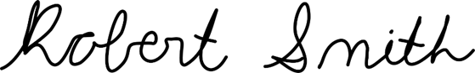 | 11/18/2022

Team members: I certify that I have reviewed the PHA worksheet, am aware of the hazards, and will ensure the control measures are followed.
Name | Signature | Date
Aaron Weingarten | 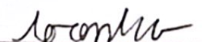 | 11/18/2022
Jack Corbin |  | 11/18/2022
Prosley Dorcely | 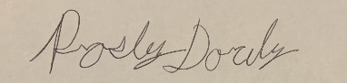 | 11/18/2022
Emily Groth | 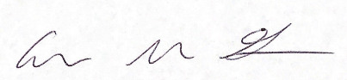 | 11/18/2022
Deepkumar Pate | 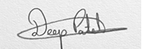 | 11/18/2022
DEFINITIONS:
Hazard: Any situation, object, or behavior that exists, or that can potentially cause ill health, injury, loss or property damage e.g. electricity, chemicals, biohazard materials, sharp objects, noise, wet floor, etc. OSHA defines hazards as “any source of potential damage, harm or adverse health effects on something or someone". A list of hazard types and examples are provided in appendix A.
Hazard control: Hazard control refers to workplace measures to eliminate/minimize adverse health effects, injury, loss, and property damage. Hazard control practices are often categorized into following three groups (priority as listed):
- Engineering control: physical modifications to a process, equipment, or installation of a barrier into a system to minimize worker exposure to a hazard. Examples are ventilation (fume hood, biological safety cabinet), containment (glove box, sealed containers, barriers), substitution/elimination (consider less hazardous alternative materials), process controls (safety valves, gauges, temperature sensor, regulators, alarms, monitors, electrical grounding and bonding), etc.
- Administrative control: changes in work procedures to reduce exposure and mitigate hazards. Examples are reducing scale of process (micro-scale experiments), reducing time of personal exposure to process, providing training on proper techniques, writing safety policies, supervision, requesting experts to perform the task, etc.
- Personal protective equipment (PPE): equipment worn to minimize exposure to hazards. Examples are gloves, safety glasses, goggles, steel toe shoes, earplugs or muffs, hard hats, respirators, vests, full body suits, laboratory coats, etc.
Team member(s): Everyone who works on the project (i.e. grads, undergrads, postdocs, etc.). The primary contact must be listed first and provide phone number and email for contact.
Safety representative: Each laboratory is encouraged to have a safety representative, preferably a graduate student, in order to facilitate the implementation of the safety expectations in the laboratory. Duties include (but are not limited to):
- Act as a point of contact between the laboratory members and the college safety committee members.
- Ensure laboratory members are following the safety rules.
- Conduct periodic safety inspection of the laboratory.
- Schedule laboratory clean up dates with the laboratory members.
- Request for hazardous waste pick up.
Residual risk: Residual Risk Assessment Matrix are used to determine project’s risk level. The hazard assessment matrix (table 1) and the residual risk assessment matrix (table2) are used to identify the residual risk category.
The instructions to use hazard assessment matrix (table 1) are listed below:
- Define the workers familiarity level to perform the task and the complexity of the task.
- Find the value associated with familiarity/complexity (1 – 5) and enter value next to: HAZARD on the PHA worksheet.
Table 1. Hazard assessment matrix.
 |  | Complexity
 |  | Simple | Moderate | Difficult
Familiarity Level | Very Familiar | 1 | 2 | 3
 | Somewhat Familiar | 2 | 3 | 4
 | Unfamiliar | 3 | 4 | 5
The instructions to use residual risk assessment matrix (table 2) are listed below:
- Identify the row associated with the familiarity/complexity value (1 – 5).
- Identify the consequences and enter value next to: CONSEQ on the PHA worksheet. Consequences are determined by defining what would happen in a worst case scenario if controls fail.
- Negligible: minor injury resulting in basic first aid treatment that can be provided on site.
- Minor: minor injury resulting in advanced first aid treatment administered by a physician.
- Moderate: injuries that require treatment above first aid but do not require hospitalization.
- Significant: severe injuries requiring hospitalization.
- Severe: death or permanent disability.
- Find the residual risk value associated with assessed hazard/consequences: Low –Low Med – Med– Med High – High.
- Enter value next to: RESIDUAL on the PHA worksheet.
Table 2. Residual risk assessment matrix.
Assessed Hazard Level | Consequences
 | Negligible | Minor | Moderate | Significant | Severe
5 | Low Med | Medium | Med High | High | High
4 | Low | Low Med | Medium | Med High | High
3 | Low | Low Med | Medium | Med High | Med High
2 | Low | Low Med | Low Med | Medium | Medium
1 | Low | Low | Low Med | Low Med | Medium

Specific rules for each category of the residual risk:
Low:
- Safety controls are planned by both the worker and supervisor.
- Proceed with supervisor authorization.
Low Med:
- Safety controls are planned by both the worker and supervisor.
- A second worker must be in place before work can proceed (buddy system).
- Proceed with supervisor authorization.
Med:
- After approval by the PI, a copy must be sent to the Safety Committee.
- A written Project Hazard Control is required and must be approved by the PI before proceeding. A copy must be sent to the Safety Committee.
- A second worker must be in place before work can proceed (buddy system).
- Limit the number of authorized workers in the hazard area.
Med High:
- After approval by the PI, the Safety Committee and/or EHS must review and approve the completed PHA.
- A written Project Hazard Control is required and must be approved by the PI and the Safety Committee before proceeding.
- Two qualified workers must be in place before work can proceed.
- Limit the number of authorized workers in the hazard area.
High:
- The activity will not be performed. The activity must be redesigned to fall in a lower hazard category.

Appendix K: Hazard Types and Examples
Types of Hazards | Example
Physical hazards | Wet floors, loose electrical cables objects protruding in walkways or doorways
Ergonomic hazards | Lifting heavy objects Stretching the body  Twisting the body  Poor desk seating
Psychological hazards | Heights, loud sounds, tunnels, bright lights
Environmental hazards | Room temperature, ventilation contaminated air, photocopiers, some office plants acids
Hazardous substances | Alkalis solvents
Biological hazards | Hepatitis B, new strain influenza
Radiation hazards | Electric welding flashes Sunburn
Chemical hazards | Effects on central nervous system, lungs, digestive system, circulatory system, skin, reproductive system. Short term (acute) effects such as burns, rashes, irritation, feeling unwell, coma and death.  Long term (chronic) effects such as mutagenic (affects cell structure), carcinogenic (cancer), teratogenic (reproductive effect), dermatitis of the skin, and occupational asthma and lung damage.
Noise | High levels of industrial noise will cause irritation in the short term, and industrial deafness in the long term.
Temperature | Personal comfort is best between temperatures of 16°C and 30°C, better between 21°C and 26°C.  Working outside these temperature ranges: may lead to becoming chilled, even hypothermia (deep body cooling) in the colder temperatures, and may lead to dehydration, cramps, heat exhaustion, and hyperthermia (heat stroke) in the warmer temperatures.
Being struck by | This hazard could be a projectile, moving object or material. The health effect could be lacerations, bruising, breaks, eye injuries, and possibly death.
Crushed by | A typical example of this hazard is tractor rollover. Death is usually the result
Entangled by | Becoming entangled in machinery. Effects could be crushing, lacerations, bruising, breaks amputation and death.
High energy sources | Explosions, high pressure gases, liquids and dusts, fires, electricity and sources such as lasers can all have serious effects on the body, even death.
Vibration | Vibration can affect the human body in the hand arm with `white-finger' or Raynaud's Syndrome, and the whole body with motion sickness, giddiness, damage to bones and audits, blood pressure and nervous system problems.
Slips, trips and falls | A very common workplace hazard from tripping on floors, falling off structures or down stairs, and slipping on spills.
Radiation | Radiation can have serious health effects. Skin cancer, other cancers, sterility, birth deformities, blood changes, skin burns and eye damage are examples.
Physical | Excessive effort, poor posture and repetition can all lead to muscular pain, tendon damage and deterioration to bones and related structures
Psychological | Stress, anxiety, tiredness, poor concentration, headaches, back pain and heart disease can be the health effects
Biological | More common in the health, food and agricultural industries. Effects such as infectious disease, rashes and allergic response.
Project Hazard Control- For Projects with Medium and Higher Risks
Name of Project: FCAAP Smart Projectile |  |  |  | Date of submission: 11/18/2022
Team member |  | Phone number |  | e-mail
Aaron Weingarten |  | 954-934-2207 |  | Apw18e@fsu.edu
Emily Groth |  | 801-300-1565 |  | Emgroth@fsu.edu
Deepkumar Patel |  | 737-615-3765 |  | Dkp18@fsu.edu
Jack Corbin |  | 850-612-0066 |  | Jc19a@fsu.edu
Prosley Dorcely |  | 305-330-0368 |  | Pd18@fsu.edu
Faculty mentor |  | Phone number |  | e-mail
Robert Smith |  |  |  | Rsmith17@fsu.edu
Rewrite the project steps to include all safety measures taken for each step or combination of steps. Be specific (don’t just state “be careful”).
Cutting/Machining: The fabrication of most parts for the assembly will be done by professionals at the machine shop. Any small alterations conducted by team members will be done while wearing the proper safety wear and with supervision.
Wiring/Soldering: Before wiring is done, it must first be determined that no power is provided to the system. This will be done by testing the current with a multimeter. Gloves will be worn when soldered with hazardous materials and a fume fan will be always on.
3D Printing: To minimize burn risks, wear gloves when handling prints and avoid reaching inside the printer unless certain it is off. 3D printing should only be done in a well-ventilated area.
Use of Wind Tunnel Equipment (Operation & Powering up/down): Only use electrical equipment that is properly grounded and ensure electrical protection devices like fuses, circuit breakers, and ground-fault circuit-interrupters (GFCI) are used appropriately. To prevent electrical fires, always keep flammable materials away from electrical circuits and experiments, and only use ‘inherently safe’ or ‘explosion proof’ electrical equipment in flammable atmospheres. Electrical PPE such as rubber gloves/sleeves, eye protection, non-flammable clothing, plastic hard hats, and insulated boots/tools should be worn appropriately.
PIV and Force Measurements: During wind tunnel testing, noises can reach very high levels depending on the conditions being run. To avoid damage to hearing, ear protection should be worn while the tunnel is running. PIV tests require the use of class 4 laser. Class 4 lasers can cause significant damage to the eyes whether it is directed or reflected. To avoid injury, protection glasses should be worn any time the laser is powered on and skin exposure should be avoided.
Thinking about the accidents that have occurred or that you have identified as a risk, describe emergency response procedures to use.
- In the event of an electrical fire, the following steps should be taken:
- 911 should be called immediately and a fire alarm should be pulled if one hasn’t gone off
- If it can be done safely, shut power off to burning area
- Help injured personnel if safe to do so
- If a small fire persists, extinguish using appropriate extinguisher

- In the event of an electrical shock, the following precautions should be taken:
- Do not enter the scene if not safe to do so
- Do not touch the victim
- Do not touch the equipment
- If safe to do so, shut off power at circuit breaker or other type of power disconnect
- If victim must be moved, do so with a non-conducting material such as a wooden broom handle
- After victim has been de-energized, contact 911 and provide first aid and CPR if certified
- Secure the area

- In the event of a gas leak, the following steps should be taken:
- Alert others and evacuate the area
- Call 911 or other appropriate responders
- Turn off the gas if safe to do so
- Move gas cylinders to safe area outdoors if safe to do so

- In the event of a chemical spill, the following steps should be taken:
- Secure the area and notify personnel
- If hazard cannot be assessed as minor, evacuate and call 911
- Consult SDS (Safety Data Sheets) and determine if spill can be managed
- Assemble spill control equipment
- Don appropriate PPE
- Absorb and containerize spilled material, including material used during clean-up
- Label the container appropriately
- Call EH&S to report the spill and have the containers picked up

- In the event of a near miss, report it to a supervisor, safety coordinator, or FSU Department of Environmental Health and Safety
- If a student sustains an injury requiring urgent medical attention, contact supervisor or department representative, and the student along with supervisor or department representative must submit an Incident Report to EH&S within 48 hours
- If a student sustains an injury requiring non-urgent medical attention, seek medical care and submit an Incident Report to EH&S within 48 hours
- For an injury requiring no medical attention, an Incident Report must still be submitted within 48 hours

List emergency response contact information:
- Call 911 for injuries, fires or other emergency situations
- Call your department representative to report a facility concern
Name | Phone number |  | Faculty or other COE emergency contact |  | Phone number
Deepkumar Patel | (737) 615-3765 |  | Dr. Rajan Kumar |  | (850) 645-0149
Emily Groth | 801-300-1565 |  | Dr. Jonas Gustavsson |  | (850) 410-6335
Aaron Weingarten | (954) 934-2207 |  | Dr. Shayne McConomy |  | (850) 410-6624
Jack Corbin | 850-612-0066
Prosley Dorcely | (305) 330-0368
Safety review signatures
Team member | Date |  | Faculty mentor |  | Date
 | 11/17/2022 |  |  |  | 11/18/2022
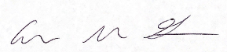 | 11/17/2022
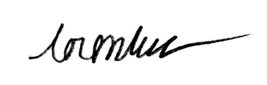 | 11/17/2022
 | 11/17/2022
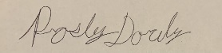 | 11/17/2022
Report all accidents and near misses to the faculty mentor.

References
There are no sources in the current document.

